|  |
| --- |
| Nanyang Polytechnic   Centre for IT Innovation  User Guide  For  Sea Transportation E Portal Services (STEPS)  Web Portal  For Administrators  Version 0.1 |

@ Copyright Nanyang Polytechnic 2020

This copyright in this work belongs to Nanyang Polytechnic. The information contained in this work is confidential and must not be reproduced or disclosed to others without the prior written permission of Nanyang Polytechnic.

**DOCUMENT CONTROL**

|  |  |  |  |
| --- | --- | --- | --- |
| **Version** | **Date** | **Prepared By** | **Changes From Previous Version** |
| 0.1 | 09-Sep-2020 | Jezreel Wong | First Draft |

Table of Contents

1 Purpose 6

2 Getting Started 6

3 User Role 6

3.1 Administrator 6

4 FUNCTIONAL GUIDE 8

4.1 Login 8

4.2 Forget password 10

4.3 Change Password 12

4.4 2-Factor Authentication 15

4.5 View Dashboards 18

*4.5.1* View Today’s Bookings 18

*4.5.2* View Average Rating of Service Provider 20

*4.5.3* View all requests pending approval 21

*4.5.4* Approve Pending Requests 22

*4.5.5* Reject Pending Requests 23

4.6 Follow-up Actions 24

*4.6.1* View Follow-up Actions – Non-compliance 24

*4.6.2* View Follow-up Actions – Reported with Issue 25

*4.6.3* Edit Follow-up Actions 26

*4.6.4* Submit Findings 27

*4.6.5* Search Follow-up Actions 28

4.7 Manage Bookings 29

*4.7.1* View Bookings 29

*4.7.2* Create Bookings – Passenger 31

*4.7.3* Create Bookings – RPL 36

*4.7.4* Approve Bookings 41

*4.7.5* Reject Bookings 44

*4.7.6* Cancel Bookings 45

*4.7.7* Edit Bookings 46

*4.7.8* Filter Bookings 47

*4.7.9* Generate Reports 48

*4.7.10* View list of no-show Bookings 51

4.8 Manage Ferry Schedules 52

*4.8.1* View Ferry Schedules 52

*4.8.2* Add new Ferry Schedule 54

*4.8.3* Edit Ferry Schedule 56

*4.8.4* Block Schedules for Bookings 57

*4.8.5* Clear Schedule 58

*4.8.6* View Schedule Template 60

*4.8.7* Add new Schedule Template 60

*4.8.8* Edit Schedule Template 60

4.9 Manage Purposes 61

*4.9.1* View list of Purposes 61

*4.9.2* Add new Purpose 61

*4.9.3* Edit Purpose 62

*4.9.4* Activate/Deactivate Purpose 63

*4.9.5* Search Purposes 64

4.10 Manage Users 66

*4.10.1* Add new user account 66

*4.10.2* View user 69

*4.10.3* Edit/Update user 71

*4.10.4* Activate/Deactivate user 74

*4.10.5* Reset user password 76

*4.10.6* Delete user 77

*4.10.7* Search Users 78

4.11 Manage Vehicles 79

*4.11.1* View list of Vehicles 79

*4.11.2* Create new Vehicle 79

*4.11.3* Edit Vehicle 81

*4.11.4* Activate/Deactivate Vehicle 82

*4.11.5* Search Vehicles 83

4.12 Manage Ferry Guidelines 84

*4.12.1* View list of Ferry Guidelines 84

*4.12.2* Add new Ferry Guidelines 85

*4.12.3* Edit Ferry Guidelines 86

*4.12.4* Activate/Deactivate Ferry Guidelines 87

*4.12.5* Search Ferry Guidelines 88

4.13 Manage Announcements 89

*4.13.1* View list of Announcements 89

*4.13.2* Add new Announcement 90

*4.13.3* Delete Announcement 91

*4.13.4* Search Announcement 92

4.14 Manage Route 93

*4.14.1* View list of Route 93

*4.14.2* Create a new Route 95

*4.14.3* Edit Route 96

*4.14.4* Activate/Deactivate Route 97

*4.14.5* Search Route 98

4.15 Manage Service Provider 99

*4.15.1* View list of Service Provider 99

*4.15.2* Create a new Service Provider 101

*4.15.3* Edit Service Provider 102

*4.15.4* Search Service Provider 103

4.16 Log out 104

# Purpose

This document provides step by step instructions on the features provided by Sea Transportation E Portal Services (STEPS) – Web Portal for administrators.

# Getting Started

To start using STEPS – Web Portal, it is recommended that your computer have the following settings:

* Google Chrome 85.0 or later.
* Screen resolution is 1024 by 768 pixels or more.

# User Role

For web portal, there will be 5 user roles – SAF Unit, Privileged User, Service Provider, Duty Personnel and Administrator, but this guide is only applicable to administrators.

## Administrator

Administrator is the key user of this website. He/she has the “super user” access to STEPS. Administrator can access the following functions:

* Login
* Forget Password
* Change Password
* Manage User Account
* Manage Ferry Schedules
* Manage Bookings
* Generate Reports
* Manage Purposes
* Manage Vehicles
* Manage Ferry Guidelines
* Manage Announcements
* Manage Routes
* Manage Service Provider

# FUNCTIONAL GUIDE

## Login

Only authenticate Administrators are allowed to use the system function.

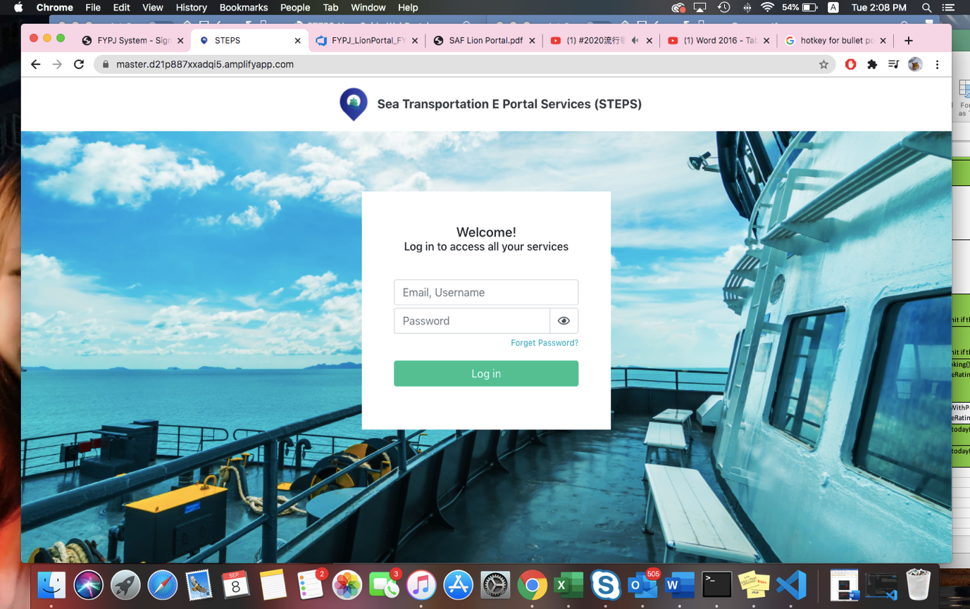

Figure 4.5.1.1: Login Page

Step 1: In the ***Email/Username*** textbox, enter your email/username.

Step 2: In the ***Password*** textbox, enter your password.

Step 3: Click on the ***Login*** button (*Figure 4.1.1*).

Authorized user will be directed to the default dashboard page (Figure 4.1.2).

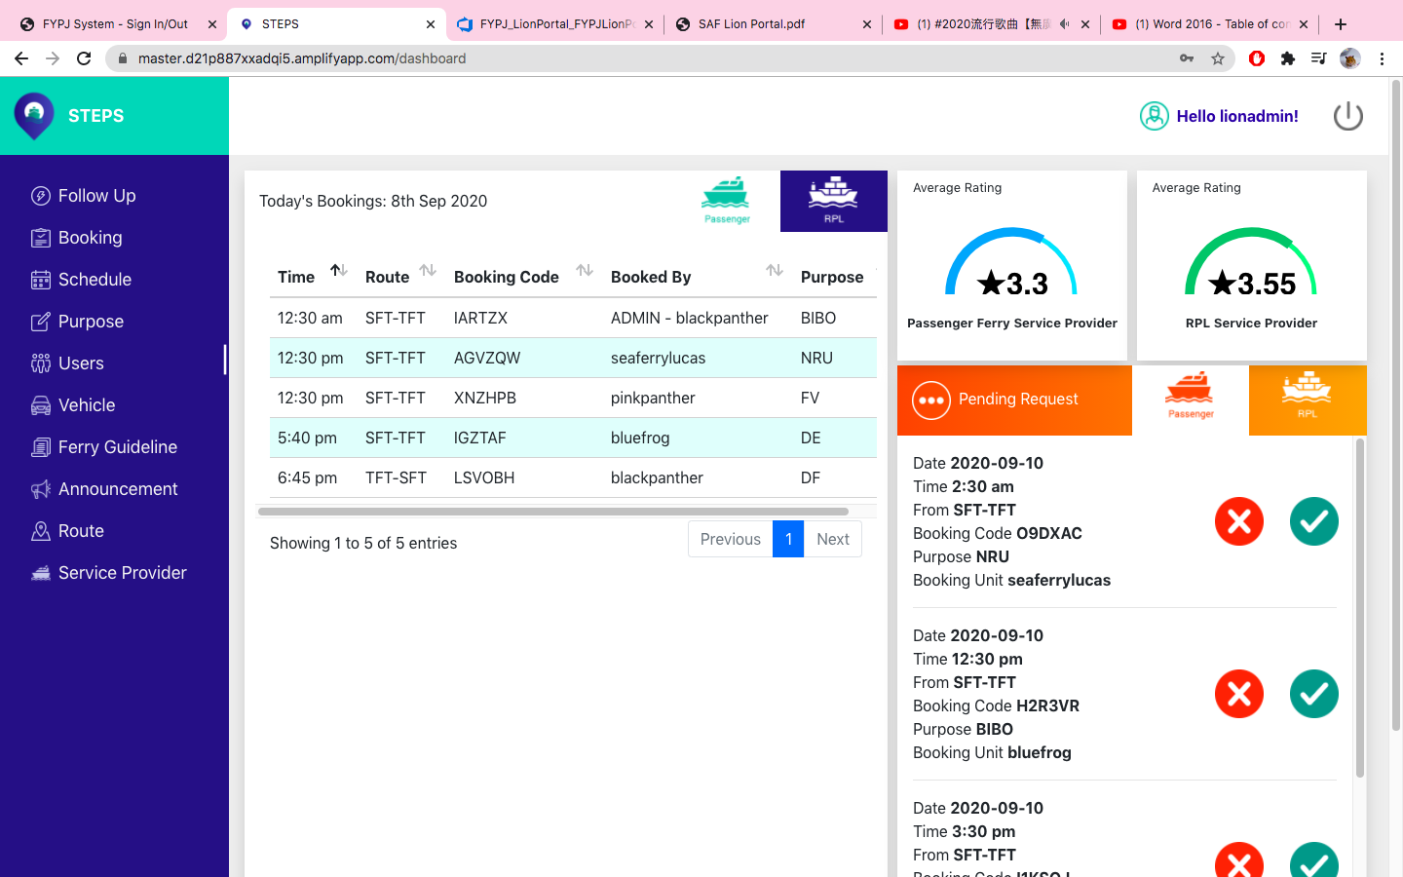

Figure 4.5.1.2: Dashboard Page

## 

## Forget password

Step 1: On the ***Login*** page, click on ***Forget Password*** hyperlink (***Figure 4.2.1***).



Figure 4.5.1.1: *Forget Password* hyperlink

**Forget Password** page will appear (**Figure 4.2.2**).

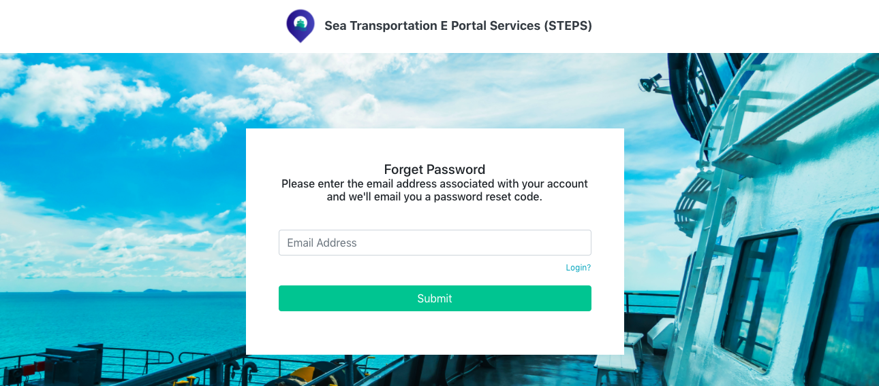

Figure 4.5.1.2: Forget Password Page

Step 2: In the ***Email Address*** textbox, enter your email address.

Step 3: Click on **Submit** button *(****Figure 4.2.3****)*.

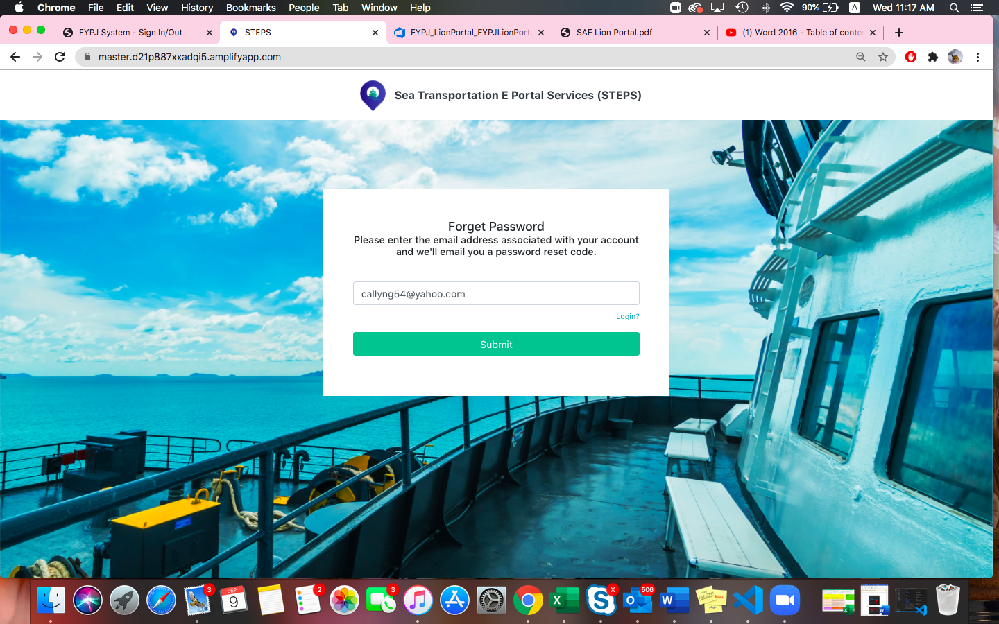

Figure 4.5.1.3: Forget Password

Step 4: An email containing a password reset code will be sent to your email address.

## Change Password

Step 1: On the ***Dashboard*** page, click on ***username*** at the top right corner. *(Figure 4.3.1)*.



Figure 4.5.1.1: Username

***Users*** Page will appear (*Figure 4.3.2*).

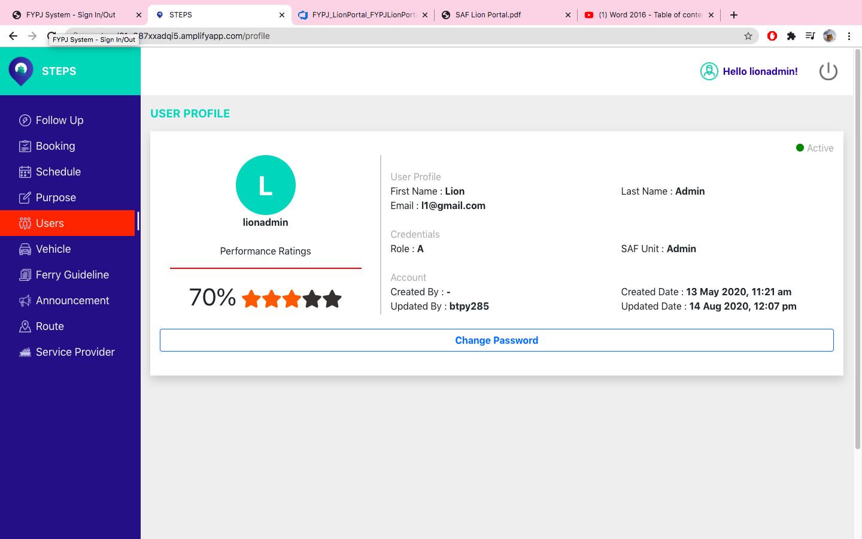

Figure 4.5.1.2: User Profile

Step 2: Click on the ***Change Password*** button (*Figure 4.3.3*).



Figure 4.5.1.3: Change Password button

A pop-up box to change password will appear (*Figure 4.3.4*).

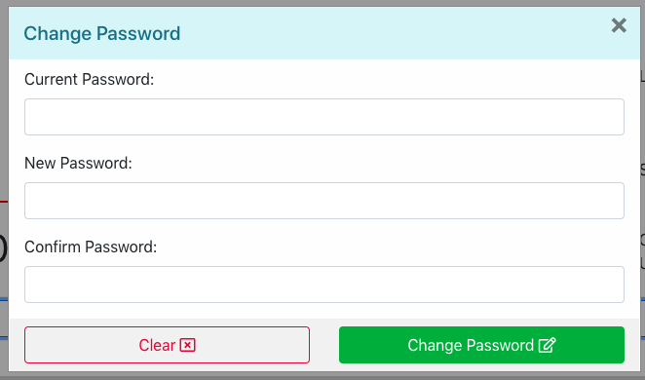

Figure 4.5.1.4: Change Password pop-up box

Step 3: In the ***Current Password*** textbox, enter current password.

Step 4: In the ***New Password*** textbox, enter new password.

(Must contain at least one number, one uppercase and lowercase letter, and at least 8 or more characters.)

Step 5: In the ***Confirm Password*** textbox, enter new password again.

Step 6: Click on “**Change Password**” button (*Figure 4.3.5*).

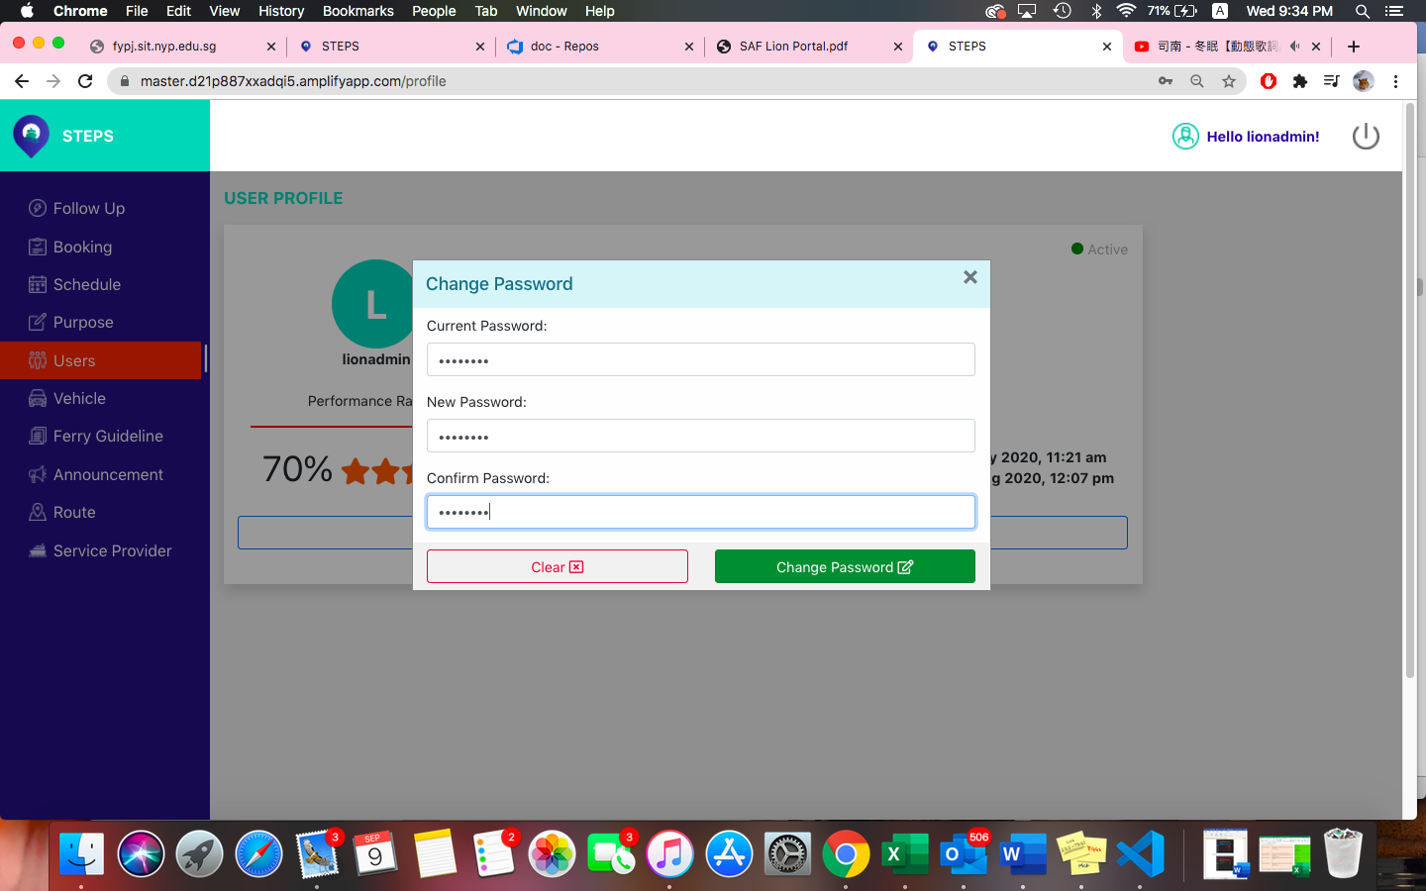

Figure 4.5.1.5: Change Password

*After which, users will be redirected back to the dashboard page.*

## 2-Factor Authentication

This function allows for improved security – by requiring a second form of identification for administrators’ accounts.

Step 1: In the ***Email/Username*** textbox, enter your email/username.

Step 2: In the ***Password*** textbox, enter your password.

Step 3: Click on the ***Login*** button (*Figure 4.4.1*)



Figure 4.5.1.1: Login Page

Step 4: Check email for STEPS Email Verification OTP (*Figure 4.4.2).*

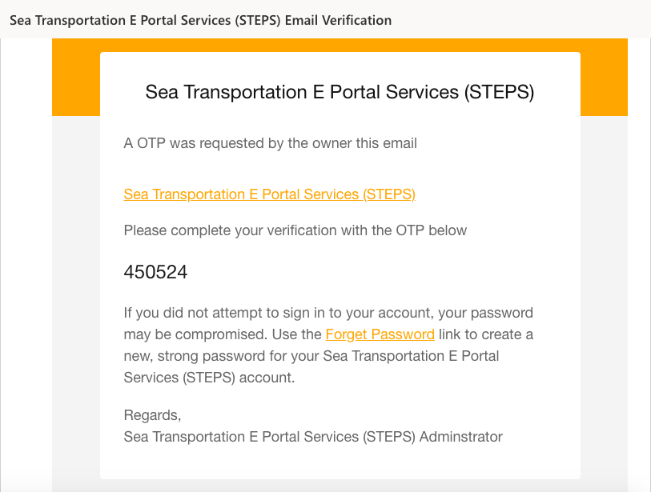

Figure 4.5.1.2: Email Verification OTP

Step 5: Enter the One-time Password.

Step 6: Click ***Verify*** button to login (*Figure 4.4.3*).

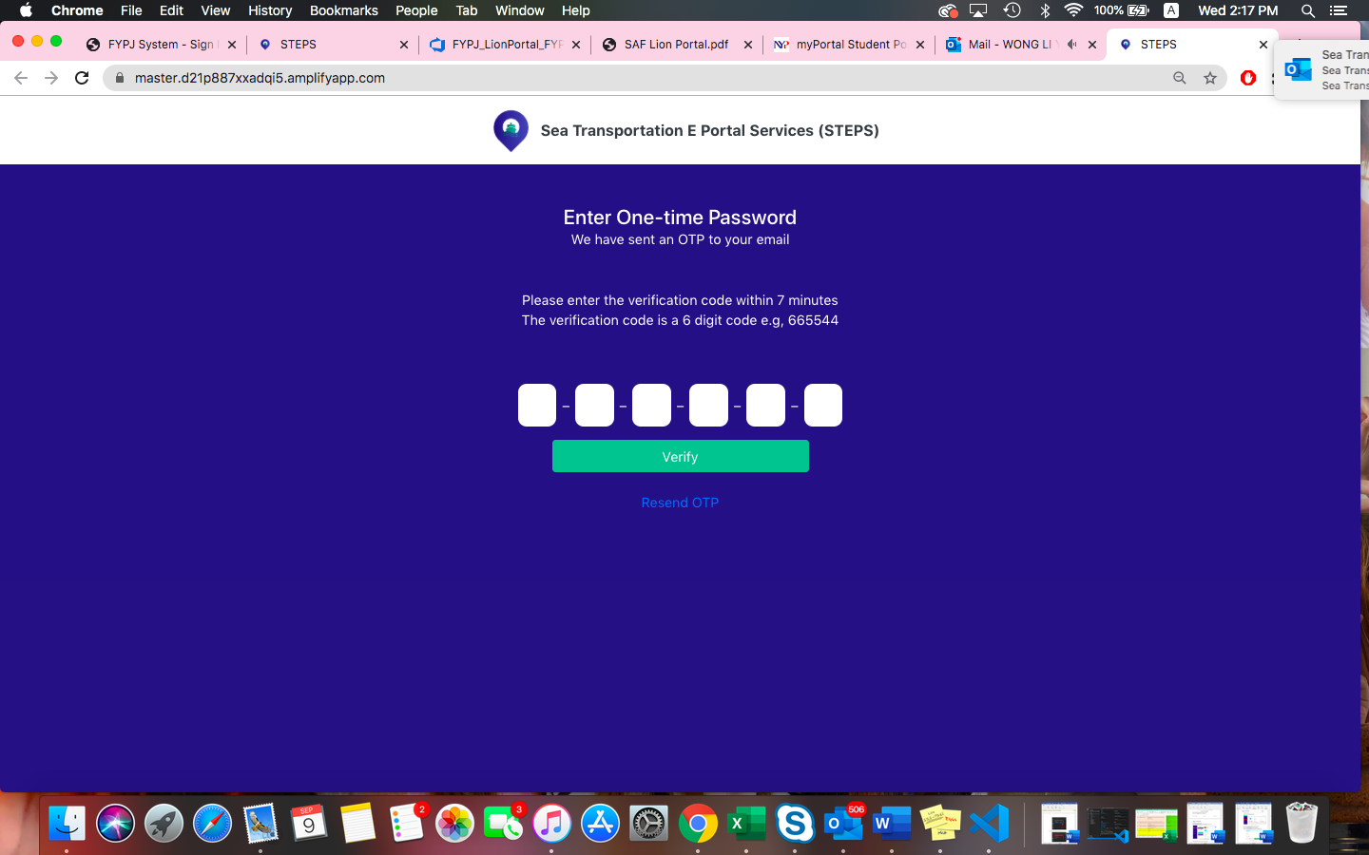

Figure 4.5.1.3: One-time Password Verification

*Authorized user will be directed to the default dashboard page (Figure 4.4.4)*



Figure 4.5.1.4: Dashboard page

## View Dashboards

The ***Dashboard*** Page is the default landing page when authorized users log in. It shows ***Today’s Bookings, Average Rating of Service Provider and Pending Requests.***

### View Today’s Bookings

On the left-hand side, bookings that occurs today will be shown with the details (*Figure 4.5.1.1*).

Users are able to toggle between the types of ferry services such as ***Passenger*** and ***RPL.***



Figure 4.5.1.1: Today’s Bookings

When a particular booking is clicked, a pop-up box displays the details of the booking.

This includes the ***Time, Route, booked by, Purpose, Booking Unit, Advanced Notice, Number of Passengers and Updated by*** (Figure 4.5.1.2)***.***

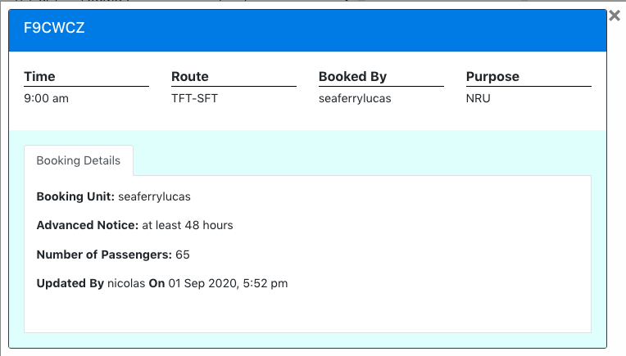 Click to close booking details.



Figure 4.5.1.2: Booking Details

### View Average Rating of Service Provider

On the top right corner, the ***Average Rating of Passenger Ferry Service Provider and RPL Service Provider*** (*Figure 4.5.2.1*)***.***

This shows the quality of the services provided.



Figure 4.5.2.1: Average Rating of Service Provider

### View all requests pending approval

On the right-hand side, it shows the pending requests for approval or rejection (*Figure 4.5.3.1*).

Administrators are able to toggle between the types of ferry services requests (Passenger and RPL) and are able to approve or reject these pending requests.



Figure 4.5.3.1: Pending Requests

### Approve Pending Requests

Under the ***Pending Requests*** section, administrators are able to approve requests of bookings by clicking on the ***tick*** button (*Figure 4.5.4.1*).

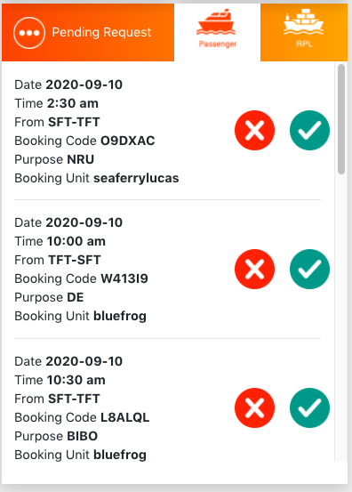

Figure 4.5.4.1: Approve Pending Requests

### Reject Pending Requests

Alternatively, under the ***Pending Requests*** section, administrators are also able to reject requests for booking by clicking the ***cross*** button (*Figure 4.5.5.1*).



Figure 4.5.5.1: Reject Pending Requests

## Follow up Actions

This function allows administrators to view and edit follow up actions that have been submitted.

It includes comments and reviews submitted by users.

### View Follow up Actions – Non-compliance

Step 1: Under the side menu bar, click on ***Follow up.***

The page displays the list of follow-up actions and the ***Non-compliance tab*** is selected by default (*Figure 4.6.1.1*).

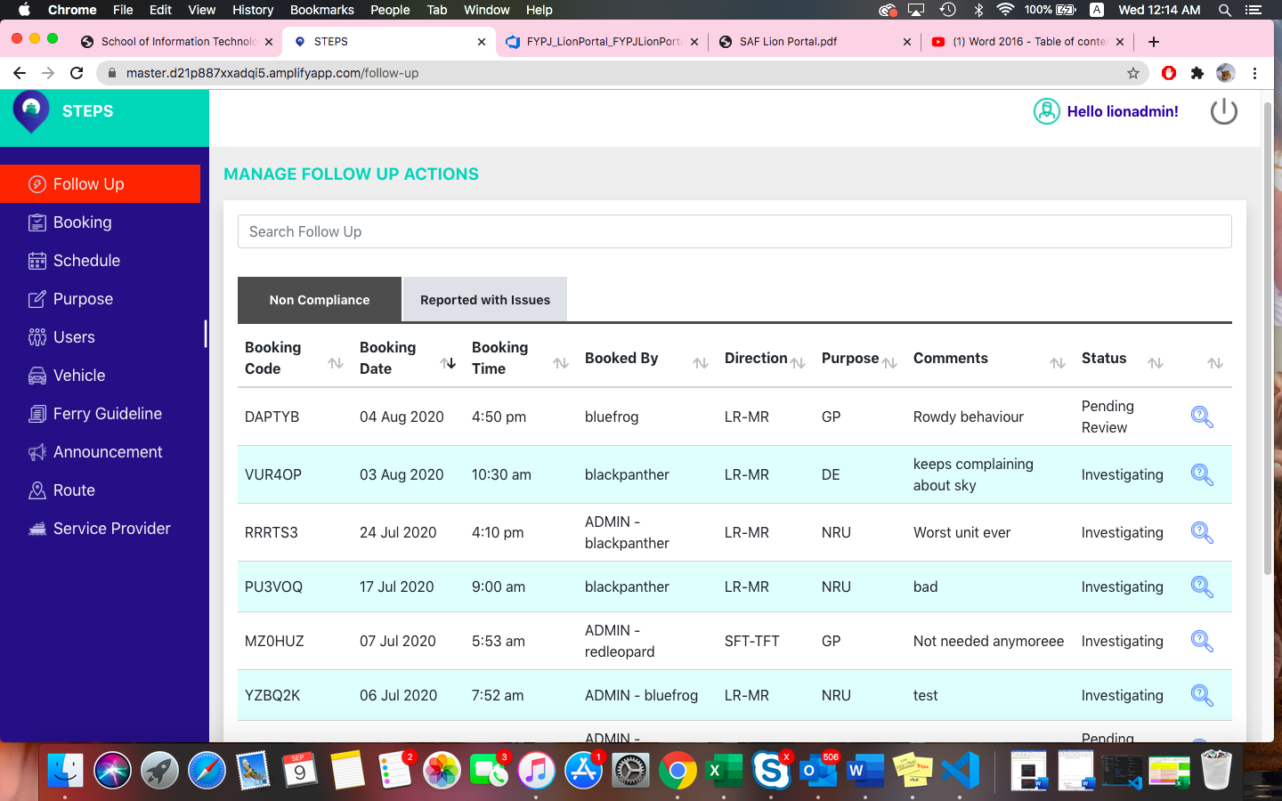

Figure 4.6.1.1: Non-compliance follow up actions

### View Follow up Actions – Reported with Issue

Step 1: On the ***Follow up page,*** click on ***Reported with Issue*** tab (*Figure 4.6.2.1*).

This displays the list of follow up actions that are reported with issue.

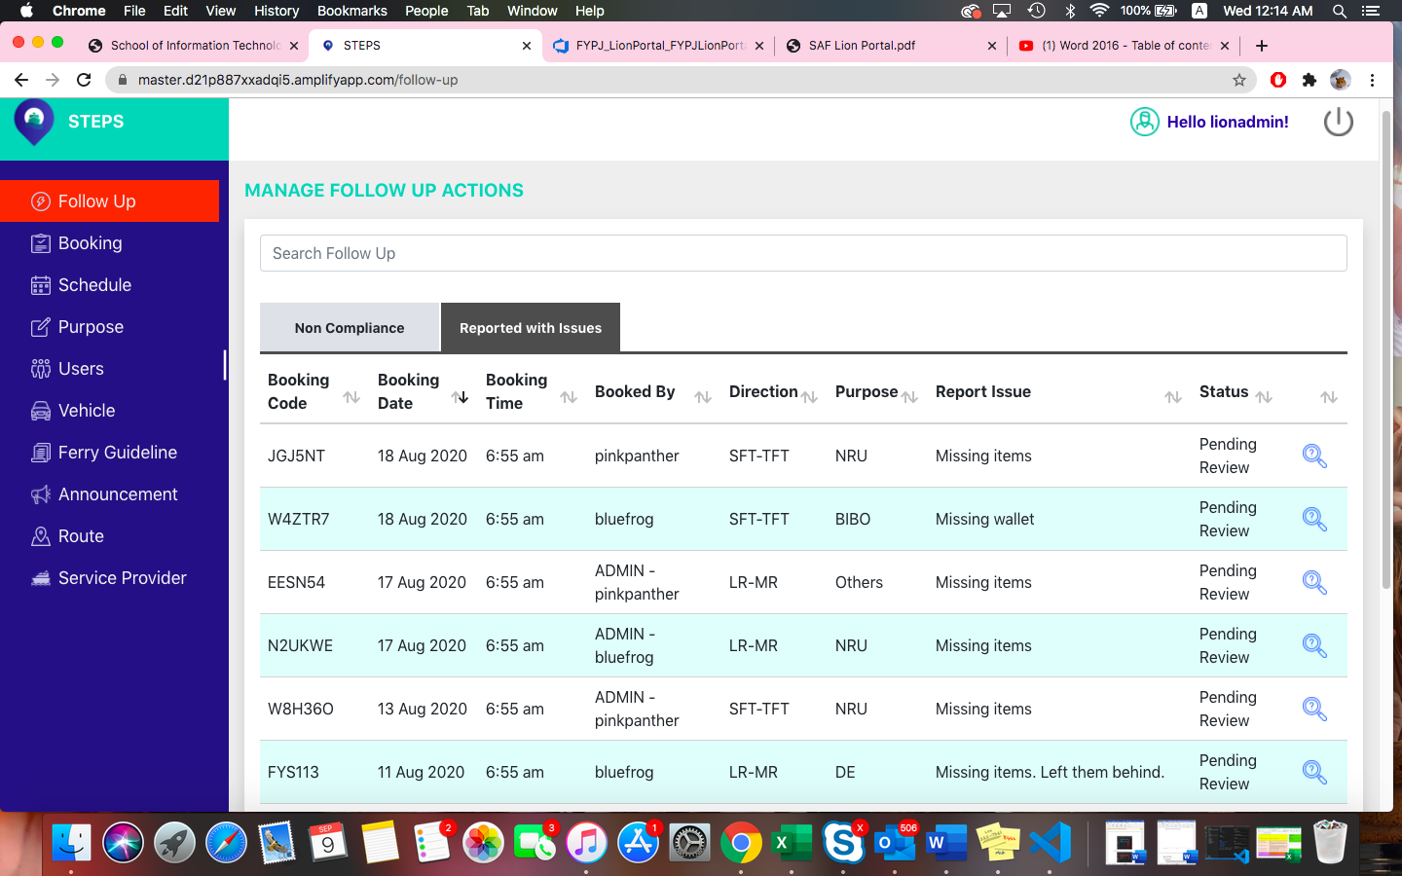

Figure 4.6.2.1: Reported with issue follow up actions

### A screenshot of a computer Description automatically generatedEdit Follow-up Actions

Step 1: On the ***Follow Up*** page, click on the button (*Figure 4.6.3.1*).



Figure 4.6.3.1: Edit follow up actions

*A pop-up box to edit follow up actions will show* **(***Figure 4.6.3.2***).**

Step 2: In the ***Findings*** textbox, enter findings.

Step 3: In the ***Status*** drop-down list, select status.

Step 4: Click on ***Update*** button to save changes (*Figure 4.6.3.2*).

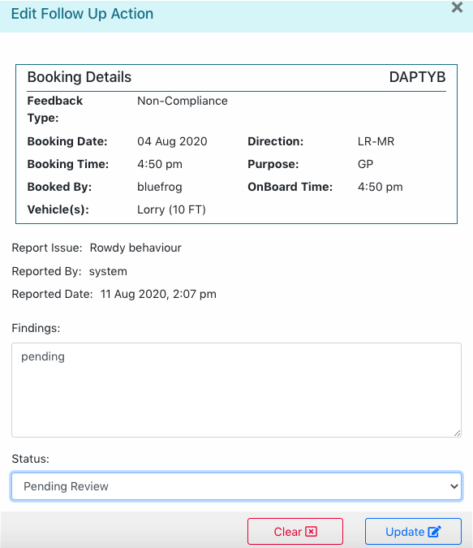

Figure 4.6.3.2: Edit follow up actions

*The page will refresh, and the edited follow up actions will be shown.*

### Submit Findings

Step 1: To submit findings on follow up actions, on the ***Edit Follow Up Action*** pop-up box***,*** type in findings.

Step 2: Click on the ***Update*** button to submit findings and save changes (*Figure 4.6.4.1*).



Figure 4.6.4.1: Submit Findings

### Search Follow-up Actions

On the ***Follow Up*** page, administrators are able to search specific follow up action options (*Figure 4.6.5.1*).



Figure 4.6.5.1: Search Follow up actions

*E.g. The list displays the results with the search term “blue” (Figure 4.6.5.2).*

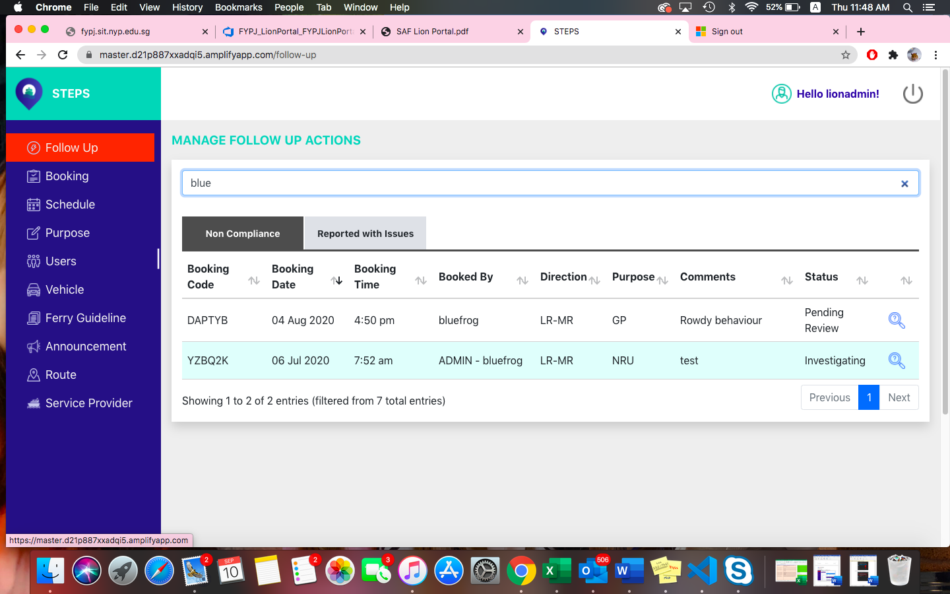

Figure 4.6.5.2: Follow up actions search term results

## Manage Bookings

This function allows the administrator to view, edit, create approve/reject, and filter bookings made by either the administrator itself or users.

### View Bookings

Step 1: Under the side menu bar, click on ***Booking*** (*Figure 4.7.1.1*)***.***

Step 2: On the right-hand side of the page, today’s bookings are being shown.

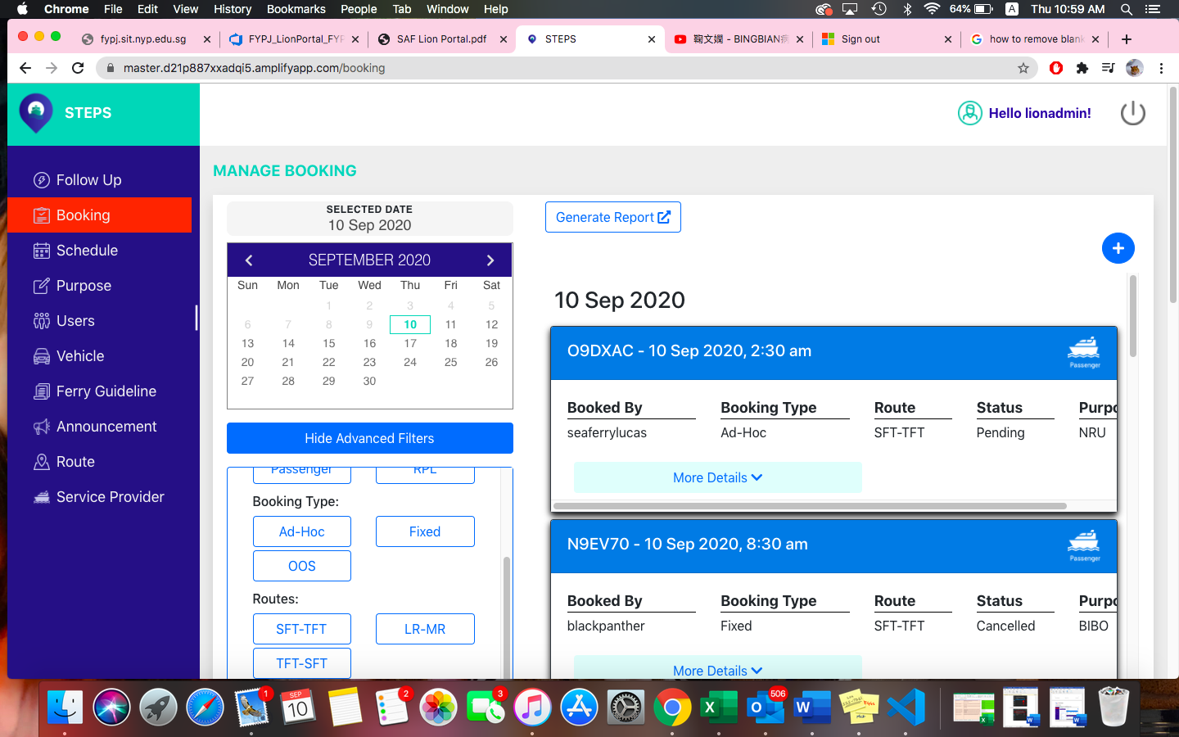

Figure 4.7.1.1: Booking Page

Step 3: Click on ***More details*** button. This shows the details of each bookings selected (*Figure 4.7.1.2*).

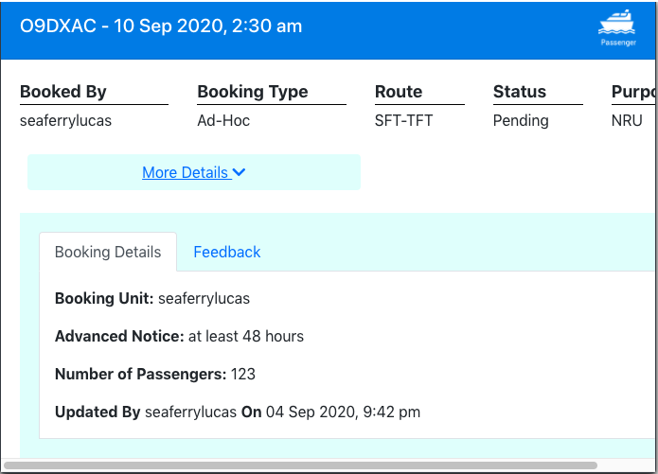

Figure 4.7.1.2: More details button

### A screenshot of a cell phone Description automatically generatedCreate Bookings – Passenger

Step 1: On the ***Booking*** page, click on the button (*Figure 4.7.2.1*).

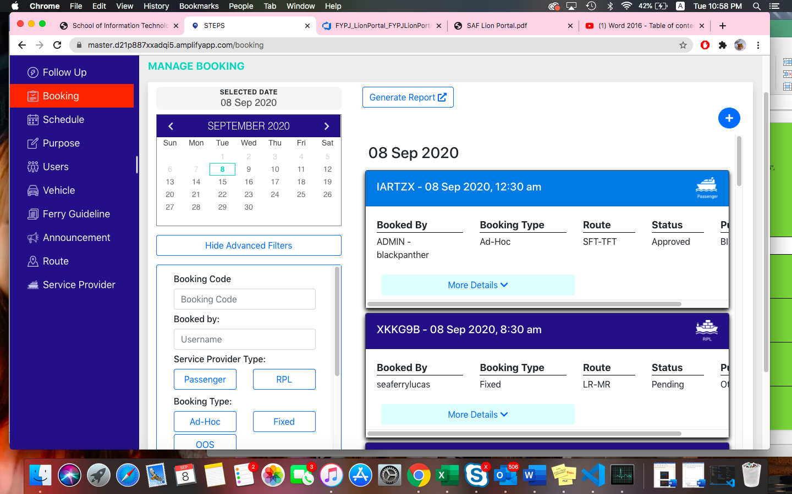

Figure 4.7.2.1: Create booking button

*A pop-up box to create booking will show (Figure 4.7.2.2).*

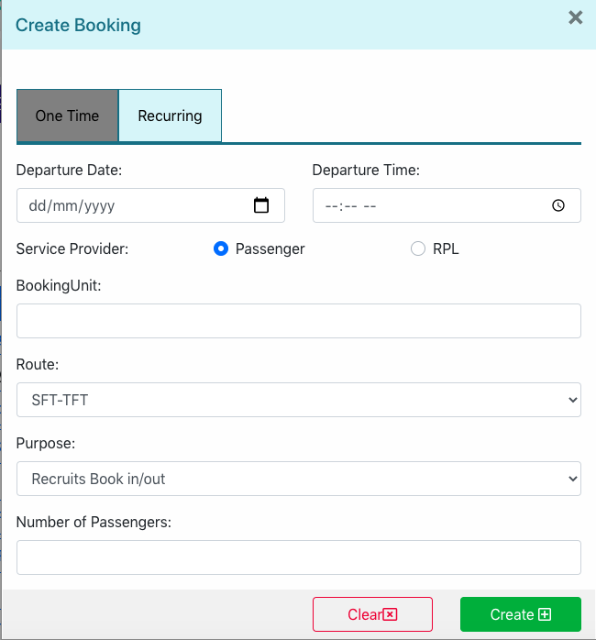

Figure 4.7.2.2: Create booking pop-up box

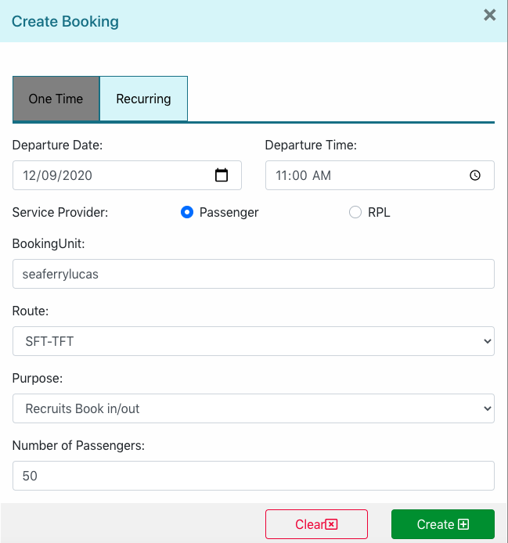

Figure 4.7.2.3

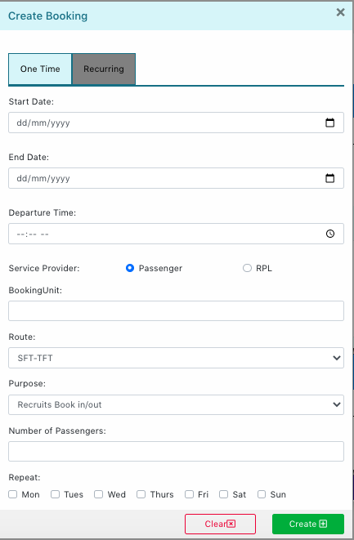

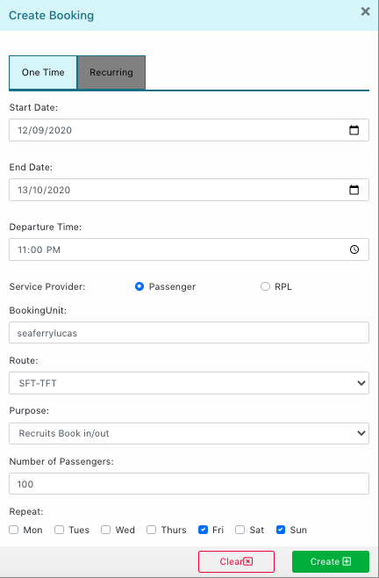

### Create Bookings – RPL



Figure 4.7.3.1

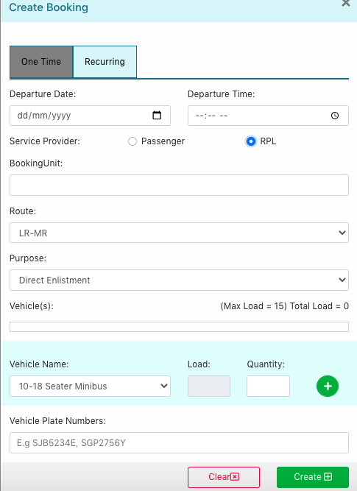

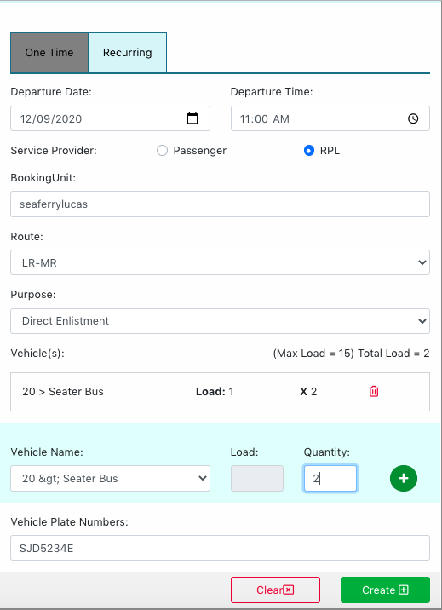

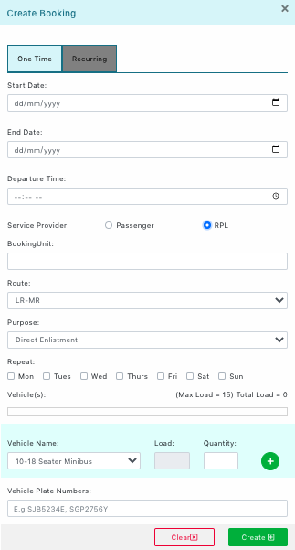

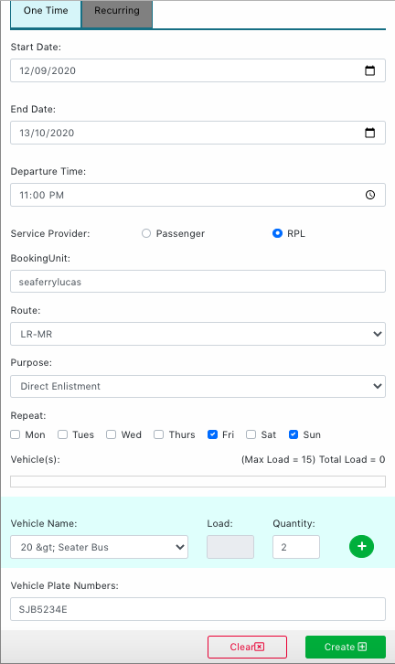

### Approve Bookings

Step 1: Under the side menu bar, click on ***STEPS.*** This will bring you back to the dashboard page (*Figure 4.7.4.1)*.



Figure 4.7.4.1: Dashboard Page

Step 2: On the right-hand side of the page, there is a ***Pending Requests*** section. This is where administrators can approve request bookings ().





Step 3: Click on the button to approve bookings ().



*Approved bookings will show on the* ***Booking*** *page.*

### A screenshot of a cell phone Description automatically generatedReject Bookings

Likewise, to reject bookings, click on the button to reject bookings (*Figure 4.7.5.1*).



Figure 4.7.5.1: Reject bookings

### Cancel Bookings

### Edit Bookings

### Filter Bookings

### Generate Reports

This function allows administrators to generate reports on bookings for data purposes.

Step 1: On the ***Booking*** page, click on ***Generate Report*** button (*Figure 4.7.9.1*).



Figure 4.7.9.1: Generate report button

Step 2: An ***Excel Spreadsheet*** of today’s booking report will be downloaded on your computer (*Figure 4.7.9.2*).



Figure 4.7.9.2: Excel Spreadsheet download

*The* ***Excel Spreadsheet*** *includes data such as* ***Booking Code, Unit Name, Capacity, Purpose, Advanced Notice, Departure Date, Booking Time, Direction, Bookings Type, Type of Service Provider, Status, SAF Feedback, SAF Feedback Type and SP Feedback Comments*** (*Figure 4.7.9.3*)***.***

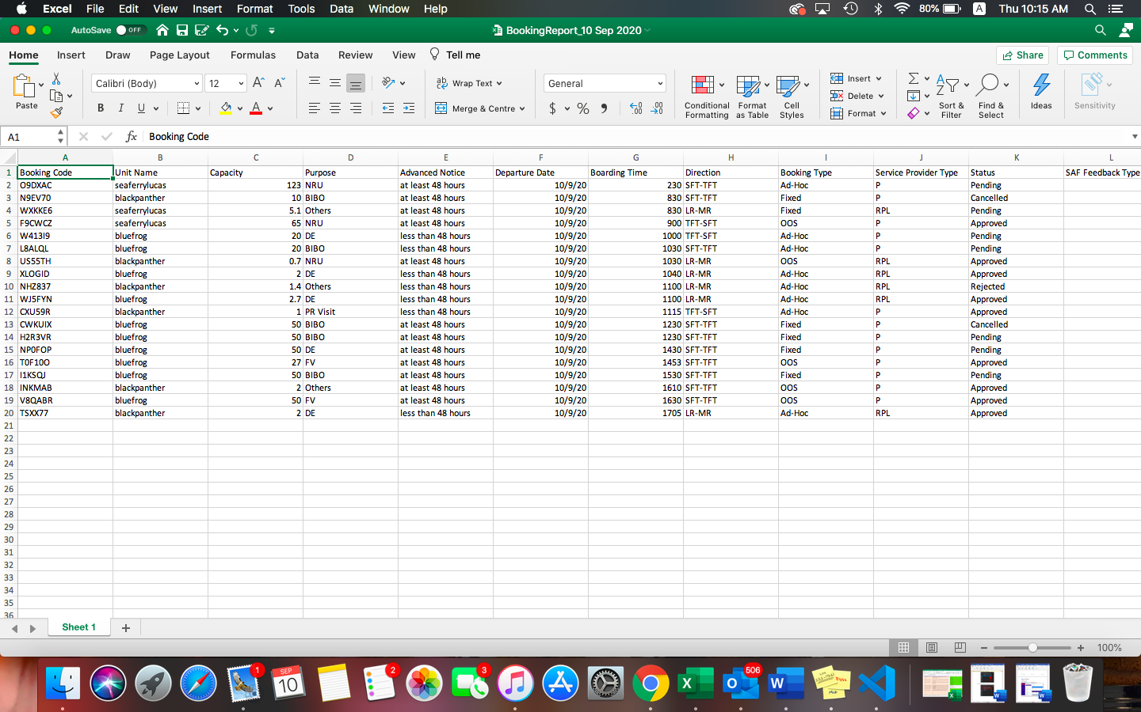

Figure 4.7.9.3: Downloaded Excel Spreadsheet

### View list of no-show Bookings

## Manage Ferry Schedules

This function allows administrators to view, create, edit, block, clear and manage schedule templates.

### View Ferry Schedules

Step 1: Under the side menu bar, click on ***Schedules.***

Step 2: Click on the ***date*** and type of ***ferry service*** ***(Passenger/RPL)*** respectively.

Step 3: Choose the route type and click on the respective ***timing*** *(Figure 4.8.1.1).*

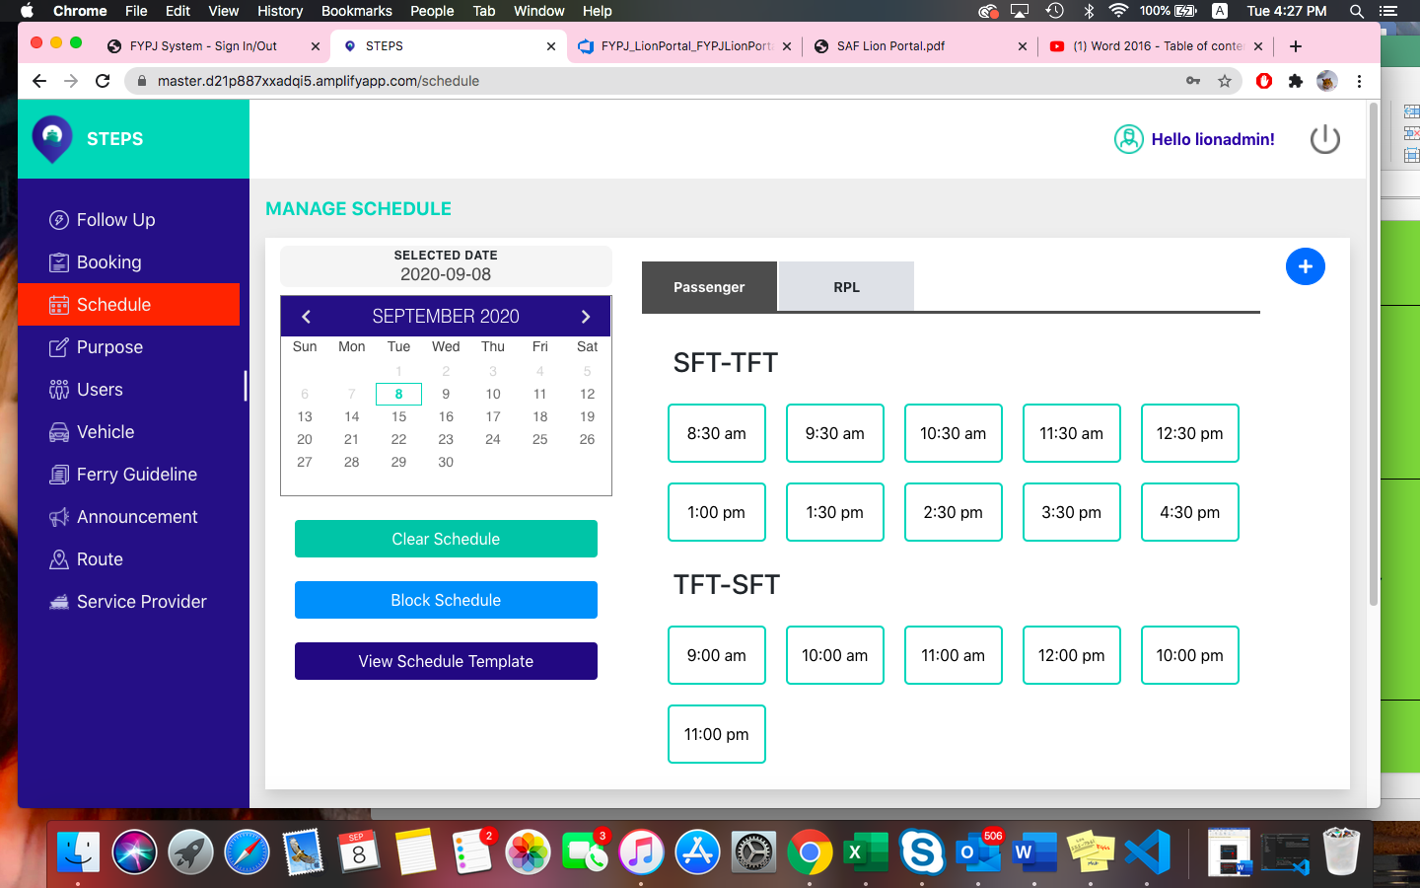

Figure 4.8.1.4.8.1.1: View Ferry Schedule

*A pop-up box with the chosen schedule details will be shown* (*Figure 4.8.1.2*).

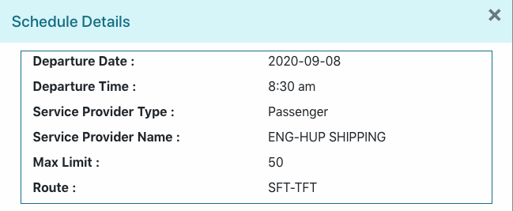

Figure 4.8.1.2: Schedule Details

### A screenshot of a cell phone Description automatically generatedAdd new Ferry Schedule

Step 1: On the ***Schedules*** page, click on the button (*Figure 4.8.2.1*).



Figure 4.8.2.1: Add new ferry schedule button

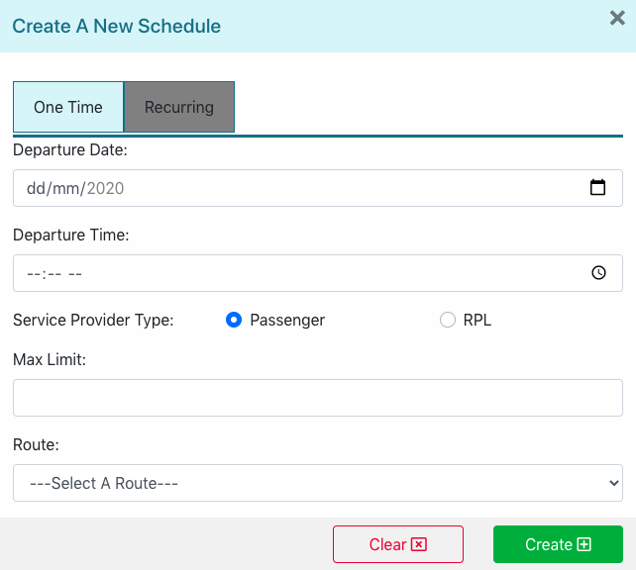

Figure 4.8.2.2

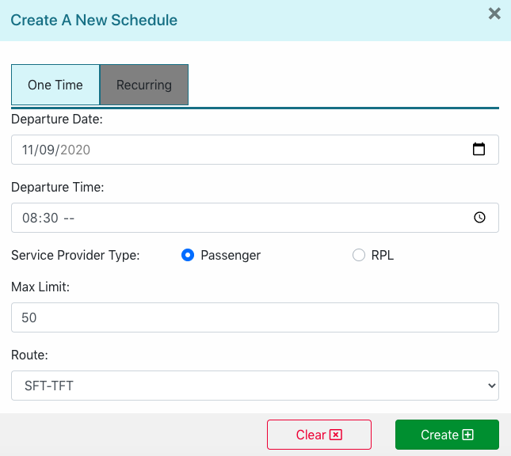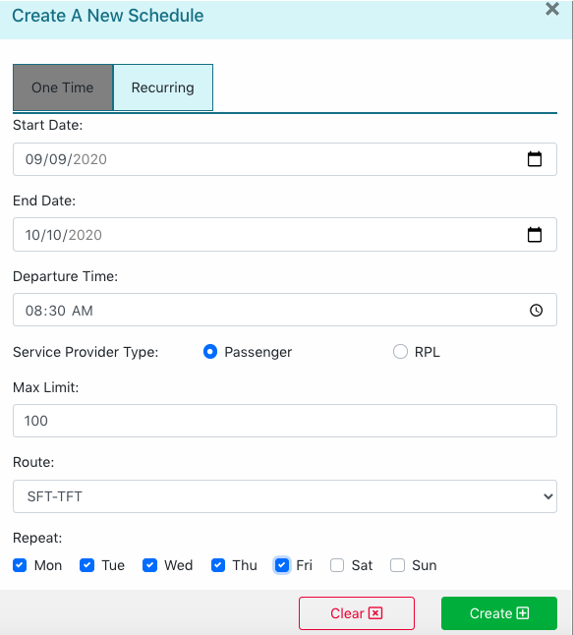

### Edit Ferry Schedule

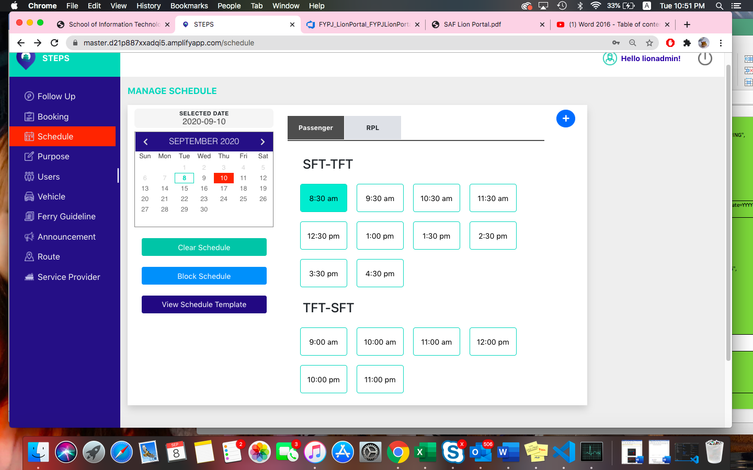

Figure 4.8.3.1

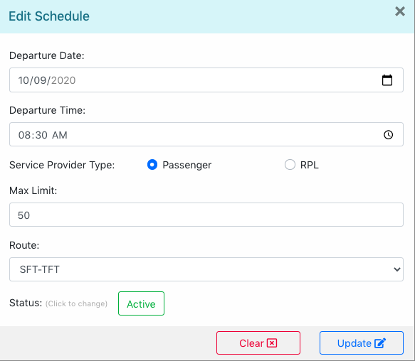

### Block Schedules for Bookings



Figure 4.8.4.1

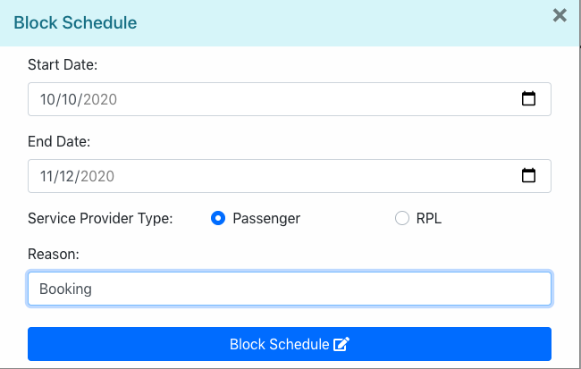

### Clear Schedule



Figure 4.8.5.1

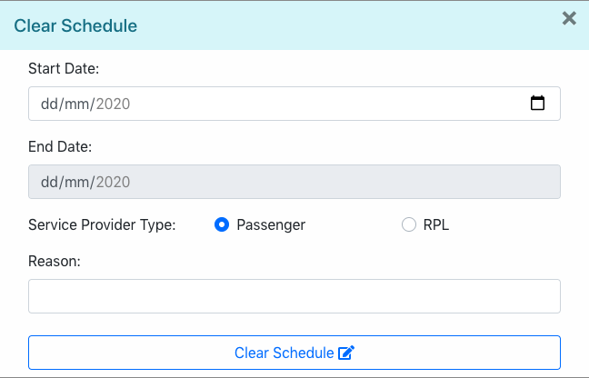

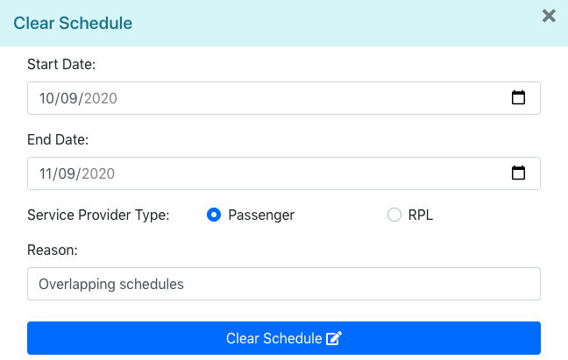

### View Schedule Template



Figure 4.8.6.1.1

### Add new Schedule Template

### Edit Schedule Template

## Manage Purposes

### View list of Purposes

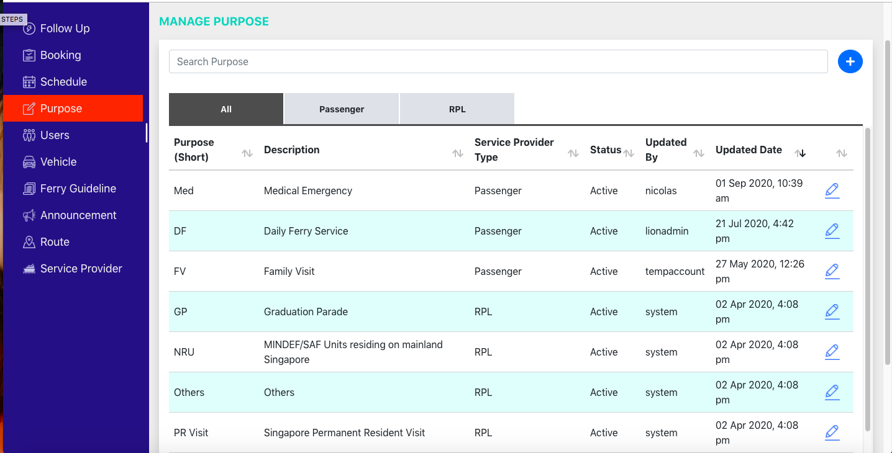

### Add new Purpose

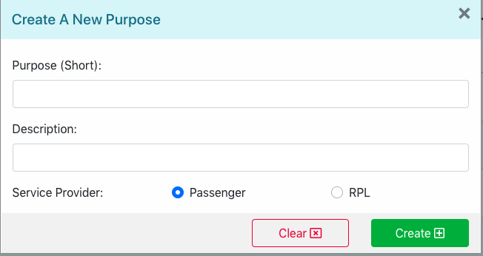

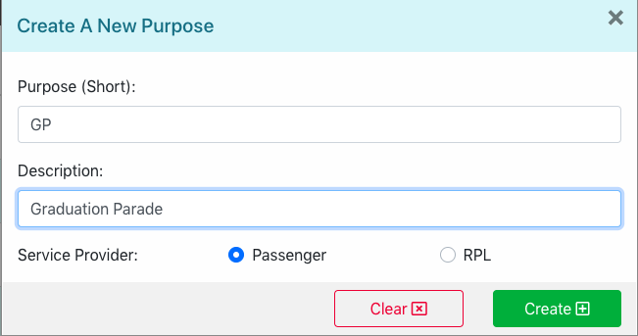

### Edit Purpose



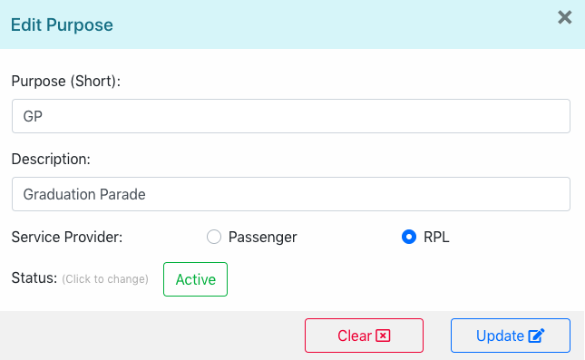

### Activate/Deactivate Purpose



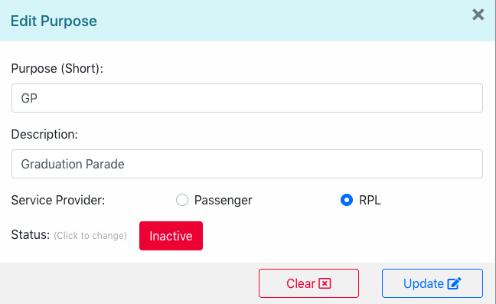

### Search Purposes



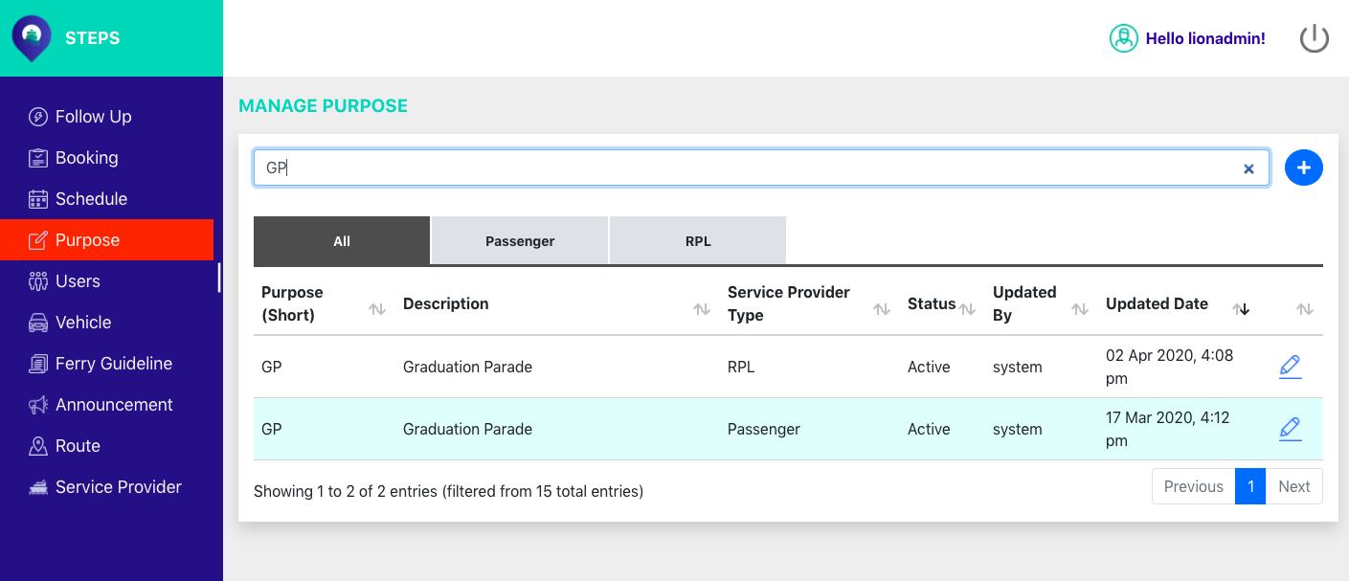

## Manage Users

This function allows administrators to create, update, delete or activate/deactivate user records.

### Add new user account

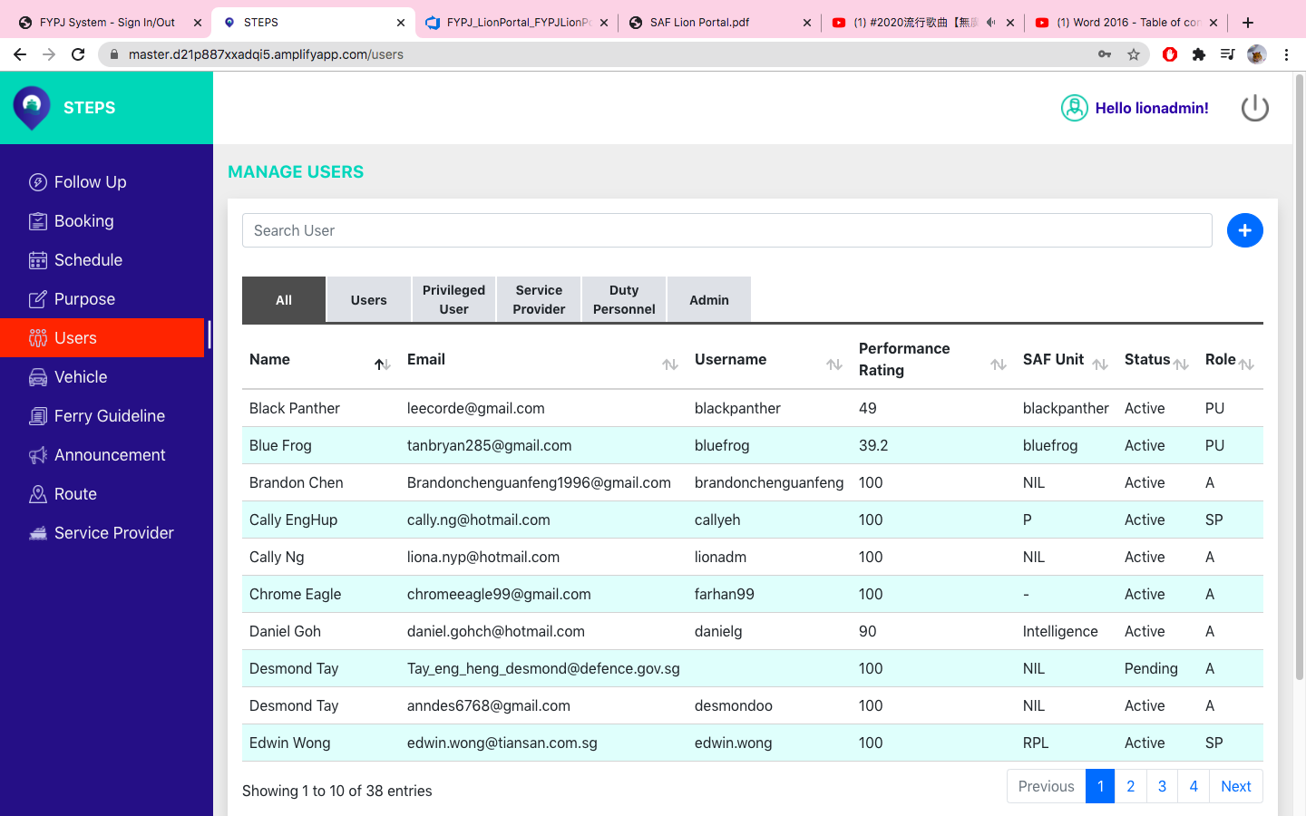Step 1: Under the side menu bar, click ***Users.***

Step 2: On the ***Users*** page, click on the button (*Figure 4.10.1.1*).



Figure 4.10.1.1: Add new user button

*A pop-up box to create a new user will show* ().

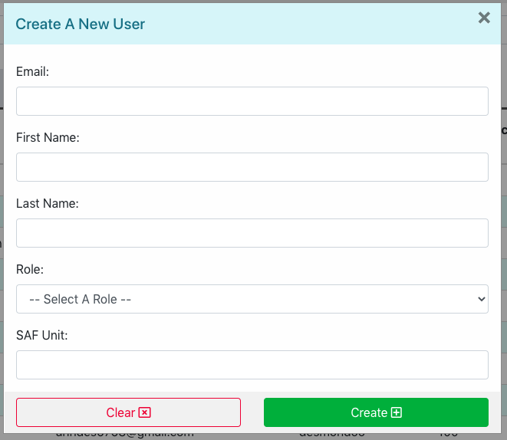

Step 3: In the **Email** textbox, enter Email.

Step 4: In the **First Name** textbox, enter first name.

Step 5: In the **Last Name** textbox, enter last name.

Step 6: Select a **Role** from the drop-down list.

Step 7: In the **SAF Unit** textbox, enter SAF Unit.

Step 8: Click on “**Create**” Button to create user ().

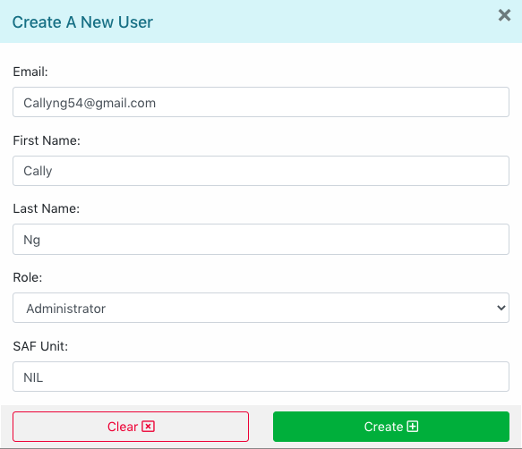

*The results will be displayed in the list of users shown.*

### View user

To view individual user records, click on the user in the list below (*Figure 4.10.2.1*).



Figure 4.10.2.1: Manage Users Page

*A pop-up box with the selected user’s information will show ().*

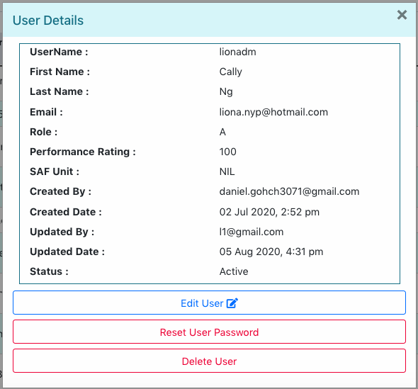

### Edit/Update user

Step 1: In the ***Users*** page, click on the user you want to edit/update (*Figure 4.10.3.1).*



Figure 4.10.3.1: Edit/Update User

*A pop-up box with the user’s information will appear.*

Step 2: Click on ***Edit User*** button ().



Step 3: In the ***First Name*** textbox, edit first name.

Step 4: In the ***Last Name*** textbox, edit last name.

Step 5: In the ***Role*** drop-down list, edit role.

Step 6: In the ***SAF Unit*** textbox, edit SAF Unit.

Step 7: In the ***Performance Rating*** textbox, edit performance rating.

Step 8: In the ***Status*** button, toggle between ***Active*** or ***Inactive*** to set status.

Step 9: Click on ***Update*** button to confirm changes ().

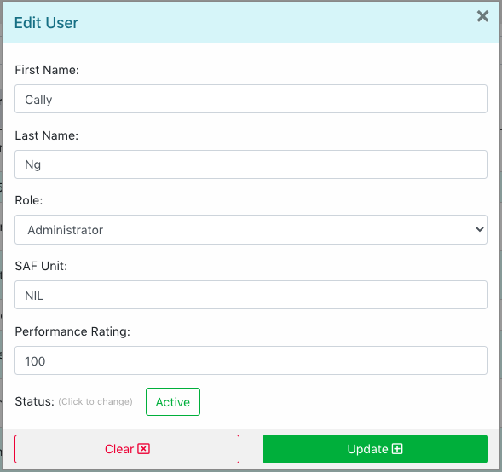

*The page will refresh, and the changes made will be shown.*

### Activate/Deactivate user

Step 1: Under the ***edit user*** button, click on the ***Active*** or ***Inactive*** button to set status of user (*Figure 4.10.4.1*).



Figure 4.10.4.1: Activate user

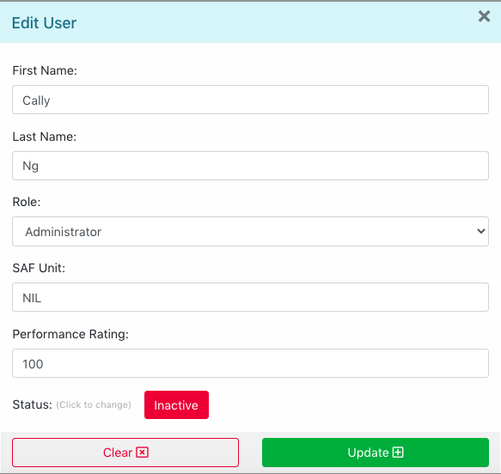

### Reset user password

To reset user password, click on ***Reset User Password*** under ***User Details*** (*Figure 4.10.5.1*).



Figure 4.10.5.1: Reset User Password

### Delete user

Step 1: Under ***User Details,*** click on ***Delete User*** button to delete user record (*Figure 4.10.6.1*).



Figure 4.10.6.1: Delete User

Step 2: A pop-up dialogue box will be prompted to delete user. Click ***OK*** button to confirm ().

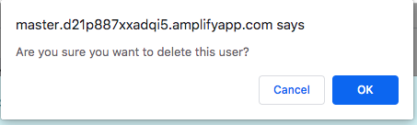

*The user page will be refreshed, and the deleted user record will be removed from the list.*

### Search Users

On the ***Users*** page, administrators are able to search for users using the ***Search Bar*** (*Figure 4.10.7.1)****.***



Figure 4.10.7.1: Search users

*E.g. The list will display results that contains the search term “Cally”.*

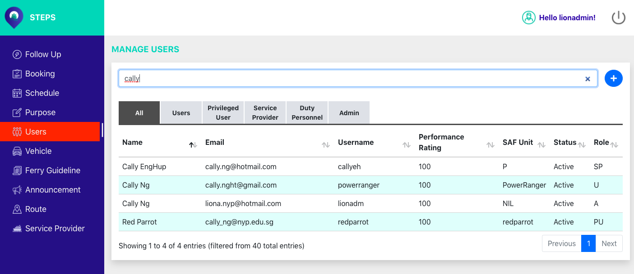

## Manage Vehicles

### View list of Vehicles

Step 1: Under the side menu bar, click on ***Vehicle*** (*Figure 4.11.1.1*).

*The page displays the list of vehicles and the details.*

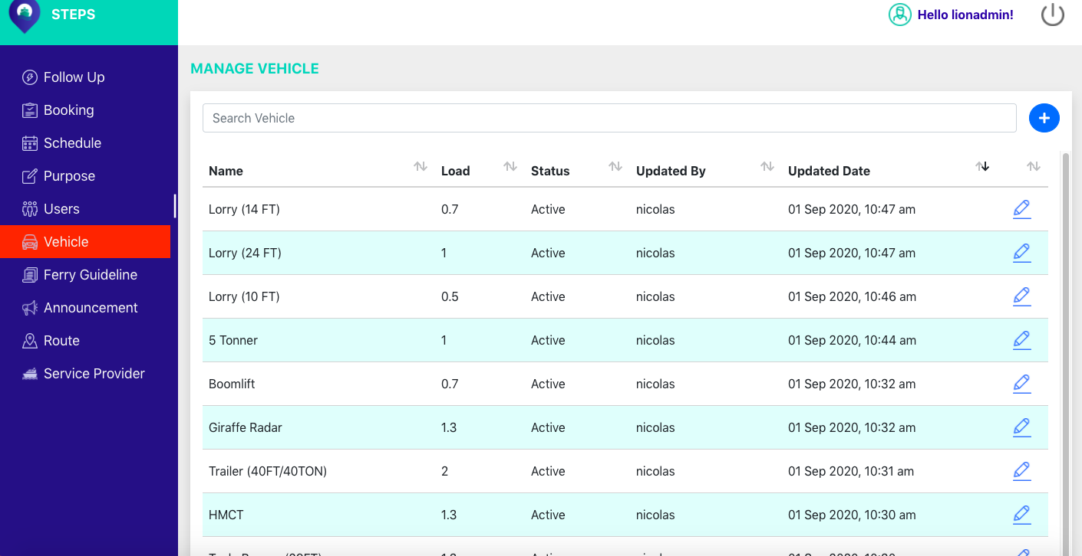

Figure 4.11.1.1: Vehicle Page

### A screenshot of a cell phone Description automatically generatedCreate new Vehicle

Step 1: On the ***Vehicle*** page, click on the button (*Figure 4.11.2.1*).



Figure 4.11.2.1: Create new vehicle button

*A pop-up box to create a new vehicle will be shown ().*

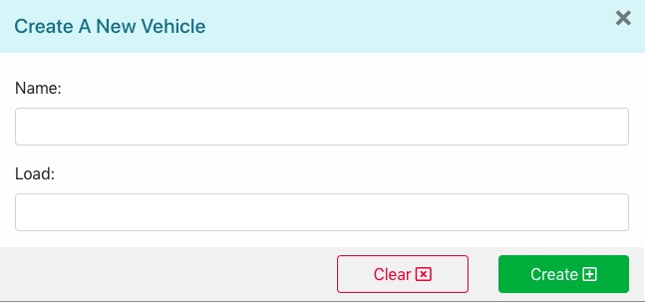

Step 2: In the ***Name*** textbox, enter name.

Step 3: In the ***Load*** textbox, enter load.

Step 4: Click on ***Create*** button to create a new vehicle ().

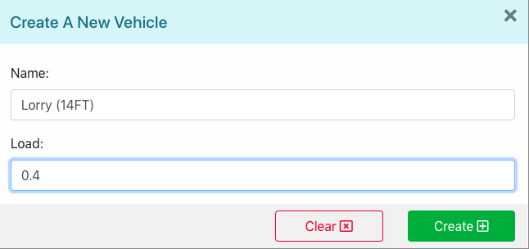

### A screenshot of a cell phone Description automatically generatedEdit Vehicle

Step 1: On the ***Vehicle*** page, click on the button (Figure 4.11.3.1).



Figure 4.11.3.1: Edit vehicle button

*A pop-up box to edit selected vehicle will show ().*

Step 2: In the ***Name*** textbox, edit name.

Step 3: In the ***Load*** textbox, edit load.

Step 4: Click on ***Update*** button to save changes.

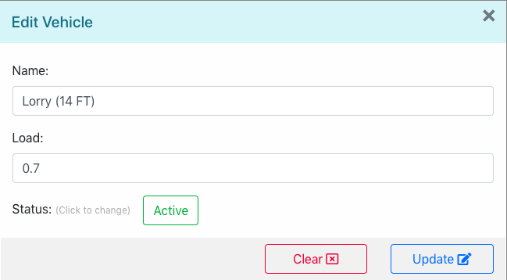

### Activate/Deactivate Vehicle

Under the ***Edit Vehicle*** pop-up box, click on ***Active*** button to make vehicle ***Inactive*** (Figure 4.11.4.1).



Figure 4.11.4.1: Deactivate Vehicle

Alternatively, to activate vehicle, click on ***Inactive*** button to make vehicle ***Active*** ()***.***

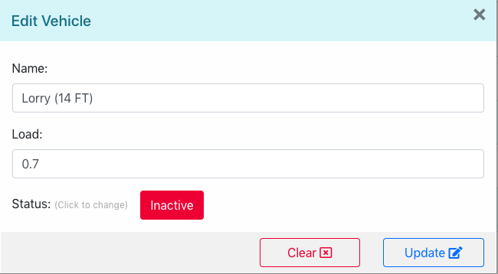

### Search Vehicles

On the ***Vehicle*** page, administrators are able to search specific vehicle or option using the search bar located at the top of the page (*Figure 4.11.5.1).*



Figure 4.11.5.1: Search Vehicle

*E.g. The list displays results that contains the search term “lorry” ().*

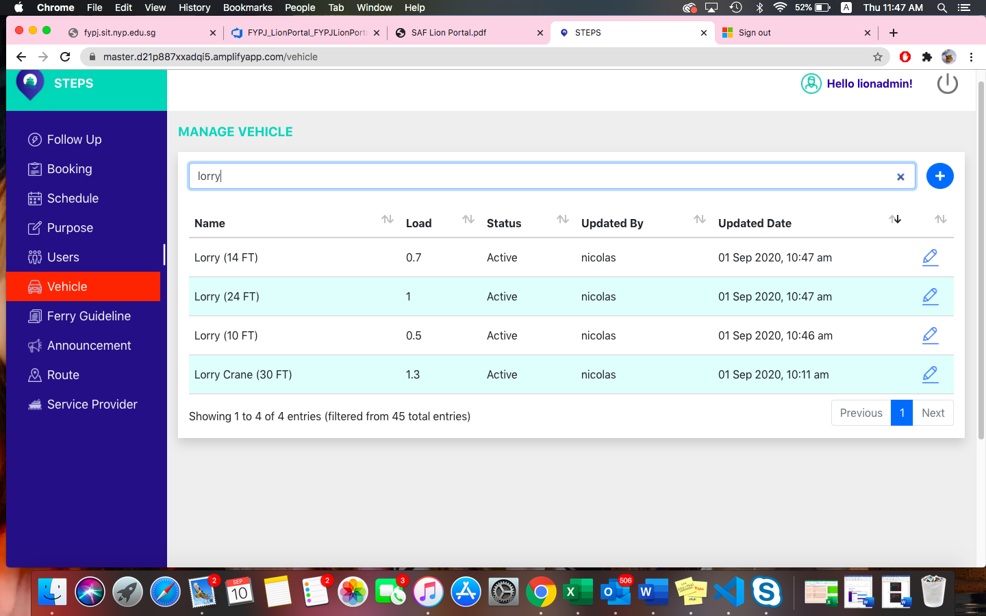

## Manage Ferry Guidelines

### View list of Ferry Guidelines

Step 1: Under the side menu bar, click on ***Ferry Guidelines*** (*Figure 4.12.1.*1).

*The page displays the list of ferry guidelines and the details.*

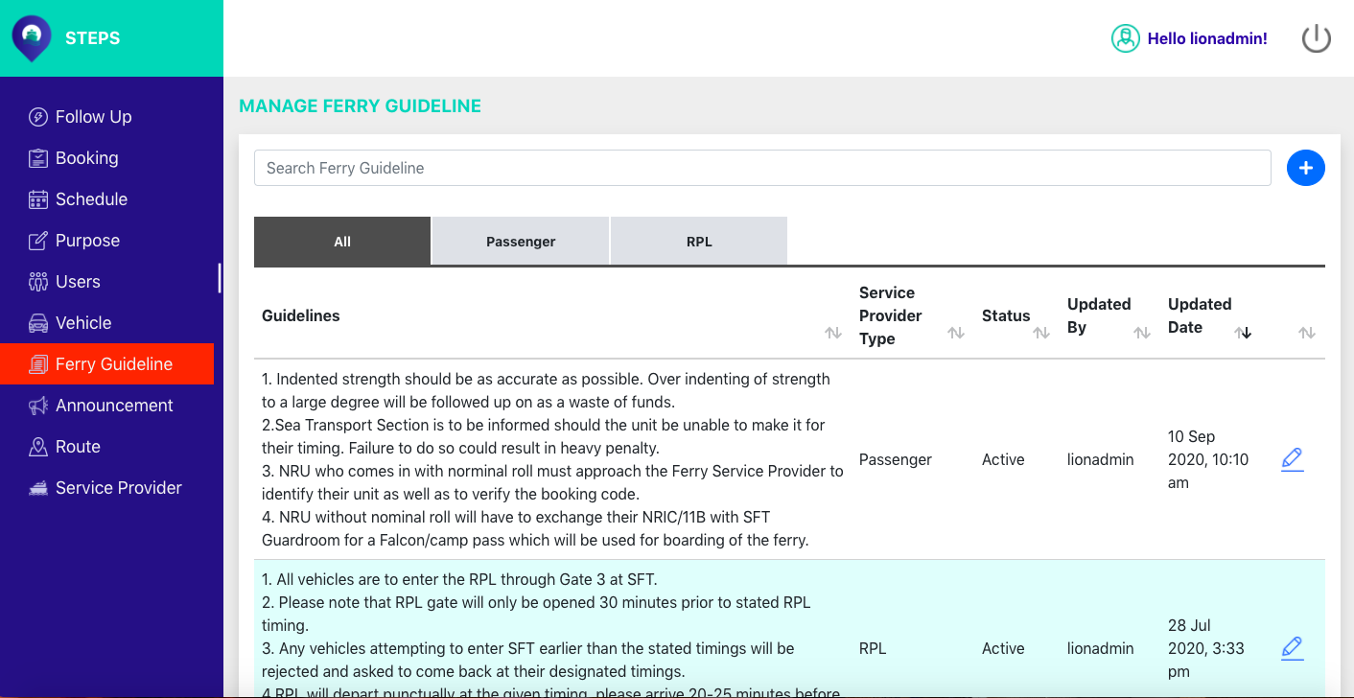

Figure 4.12.1.1: Ferry Guidelines page

*Users are able to toggle among the ferry guidelines according to the ferry services tabs, such as* ***All, Passenger or RPL.***

*Passenger Tab* ()*.*

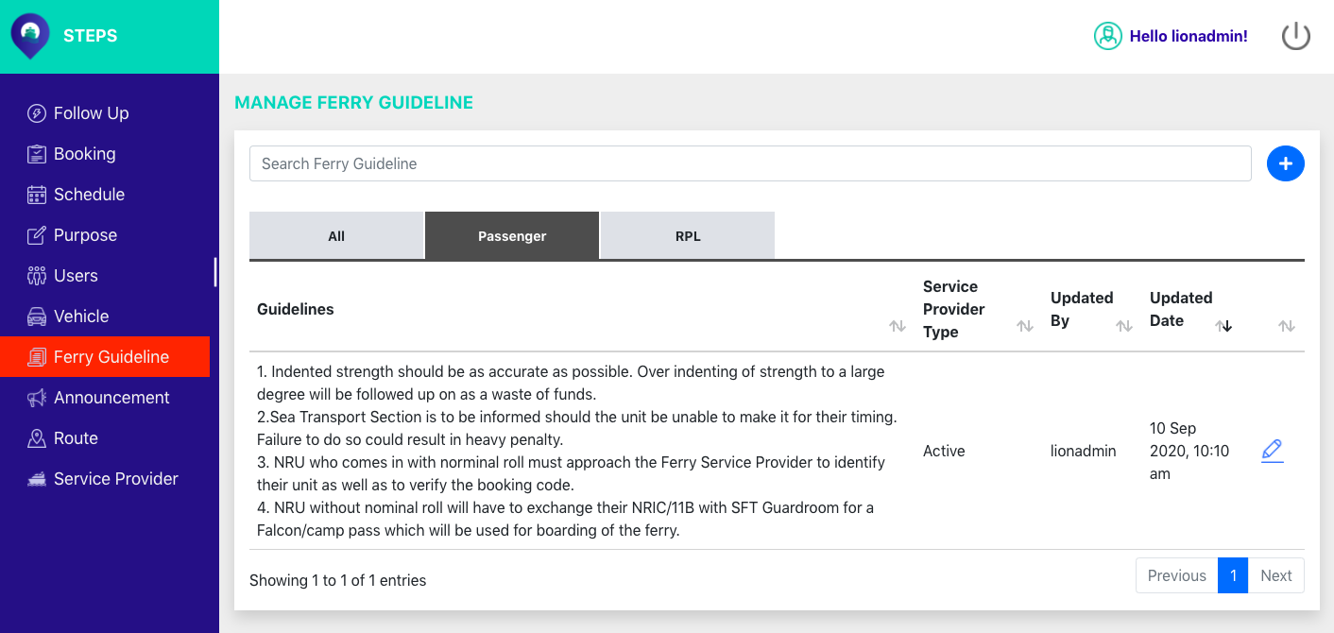

*RPL Tab* ().

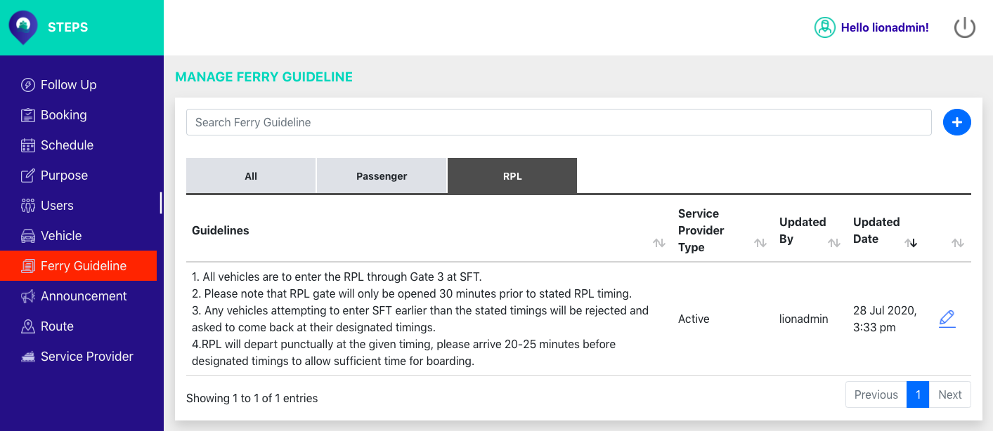

### A screenshot of a cell phone Description automatically generatedAdd new Ferry Guidelines

Step 1: On the ***Ferry Guidelines*** page, click on the button (*Figure 4.12.2.1*).



Figure 4.12.2.1: Create new ferry guideline button

*A pop-up box to create a new ferry guideline will show* (*Figure 4.12.2.2*).

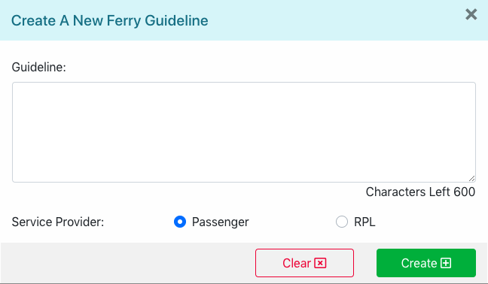

Figure 4.12.2.2: Create a new ferry guideline pop-up box

Step 2: In the ***Guideline*** textbox, enter guideline.

Step 3: In the ***Service Provider*** option, select service provide (Passenger/RPL).

Step 4: Click on ***Create*** button to create a new ferry guideline (*Figure 4.12.2.3*).

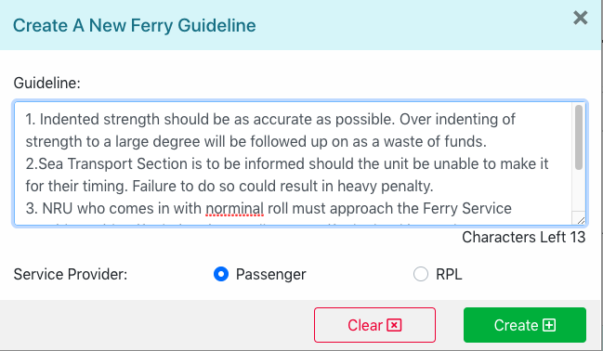

Figure 4.12.2.3: Create a new ferry guideline

*The page will refresh, and the new ferry guideline added to the list will be shown.*

### Edit Ferry Guidelines

Step 1:



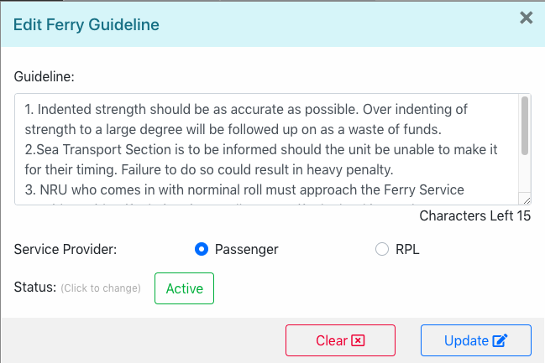

### Activate/Deactivate Ferry Guidelines



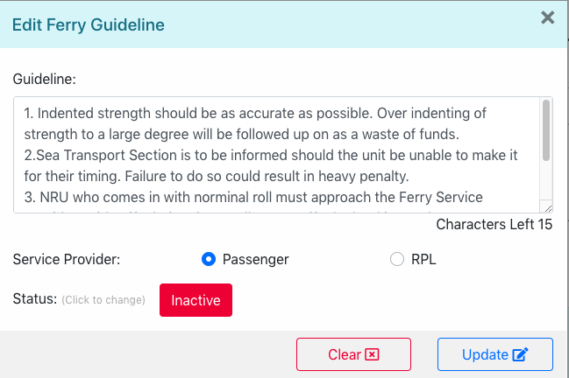

### Search Ferry Guidelines



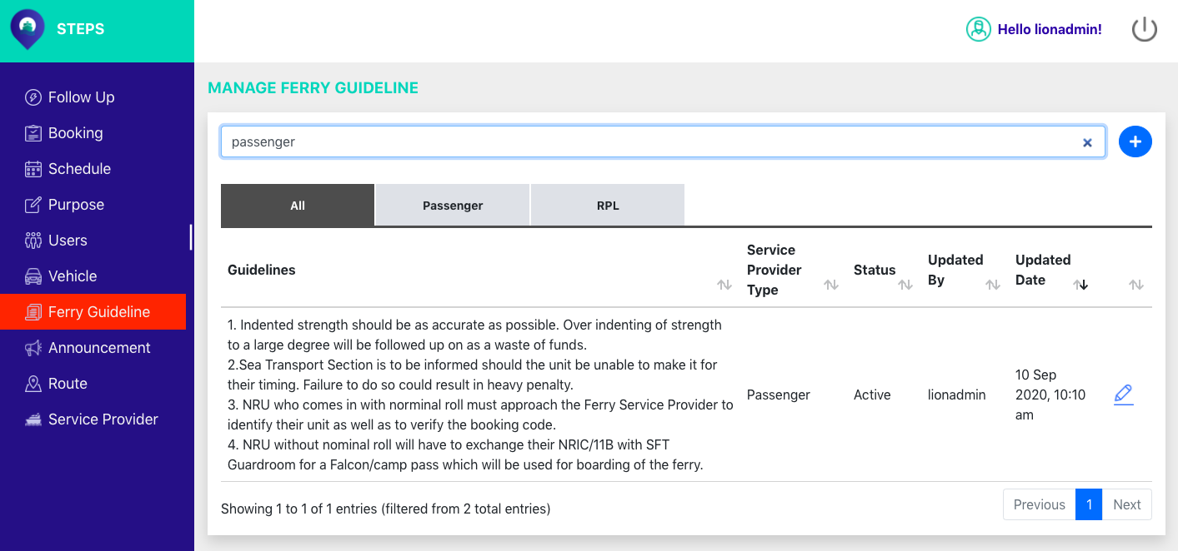

## Manage Announcements

### View list of Announcements

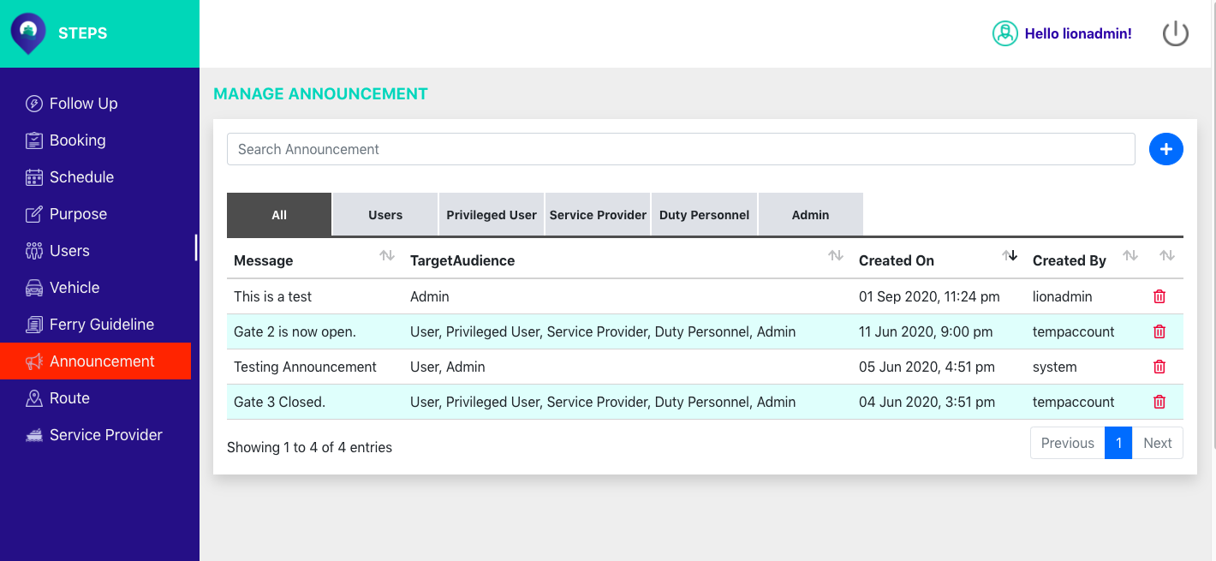

### Add new Announcement

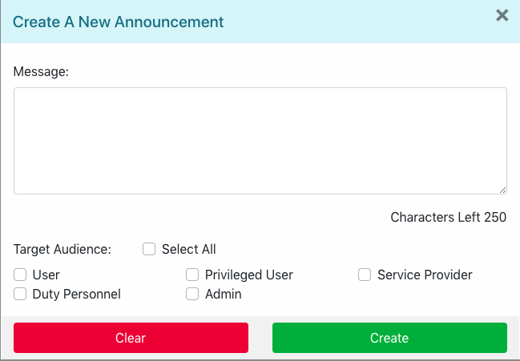

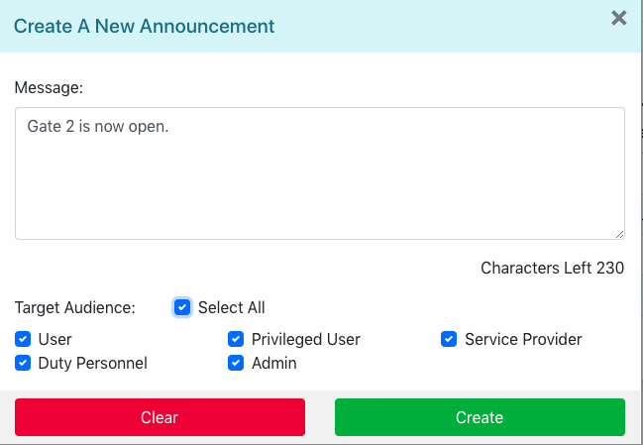

### Delete Announcement



### Search Announcement



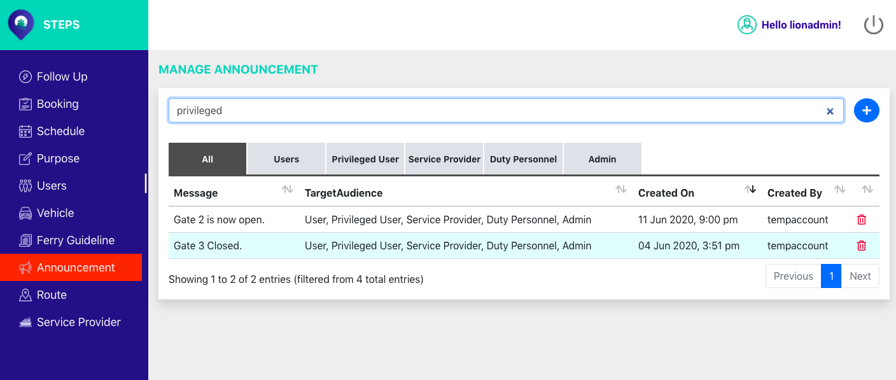

## Manage Route

### View list of Route

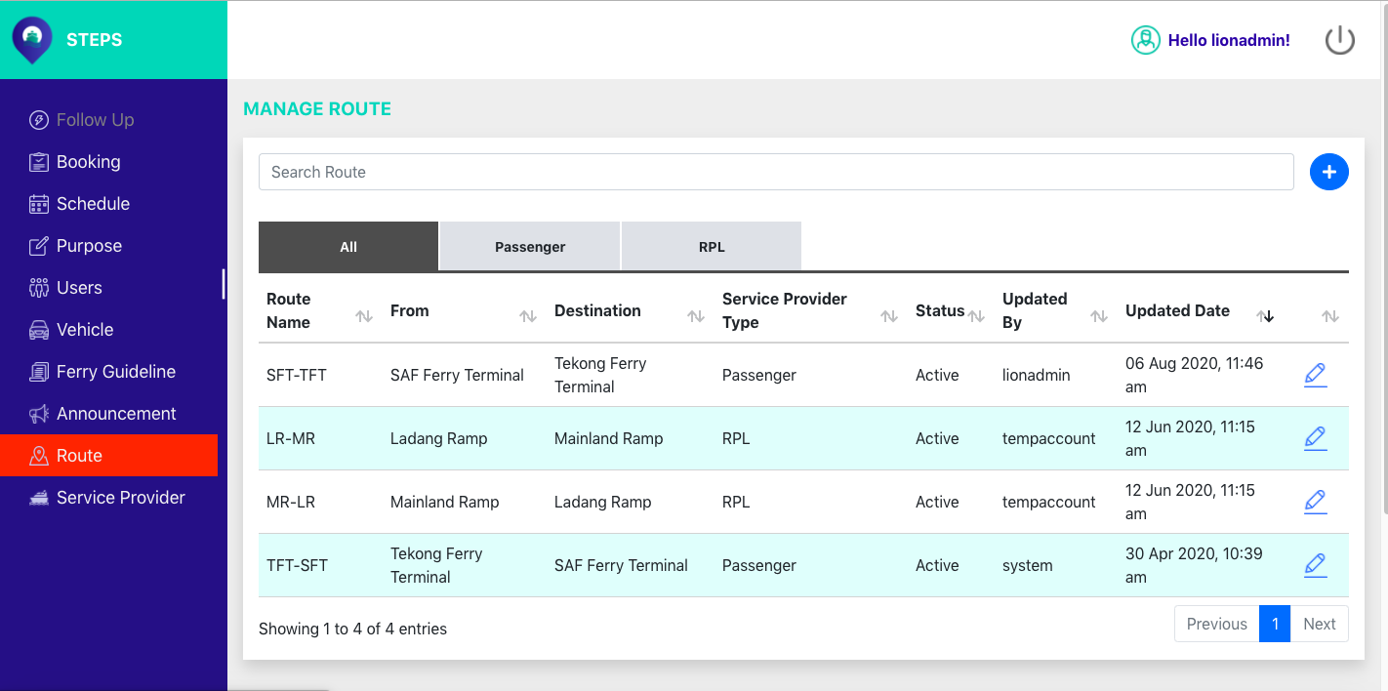

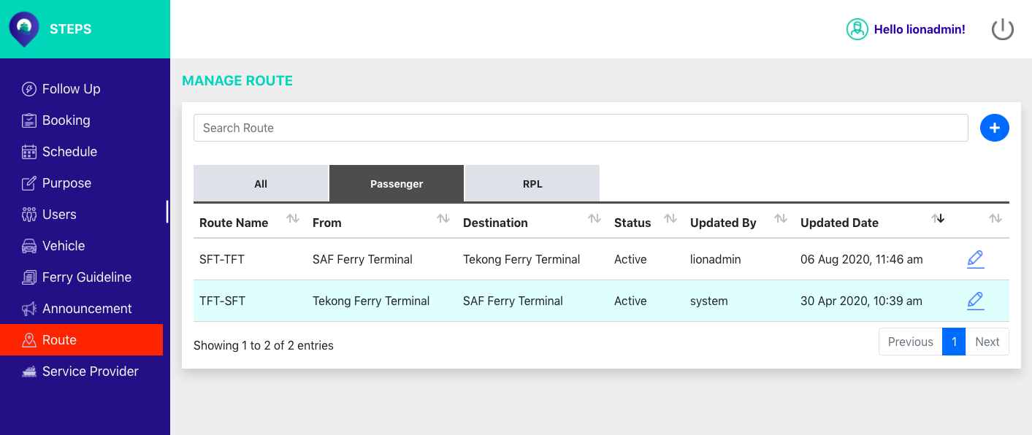

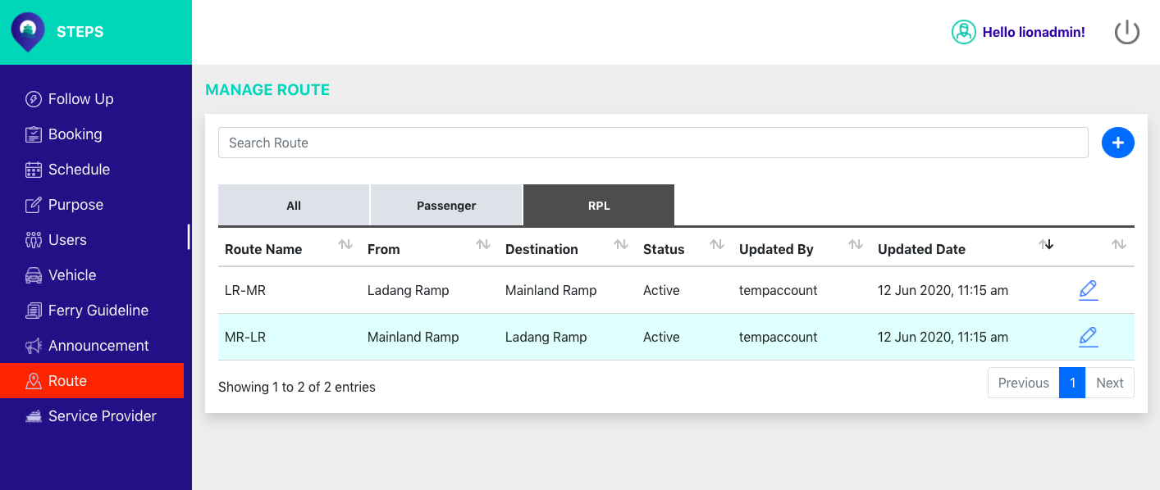

### Create a new Route

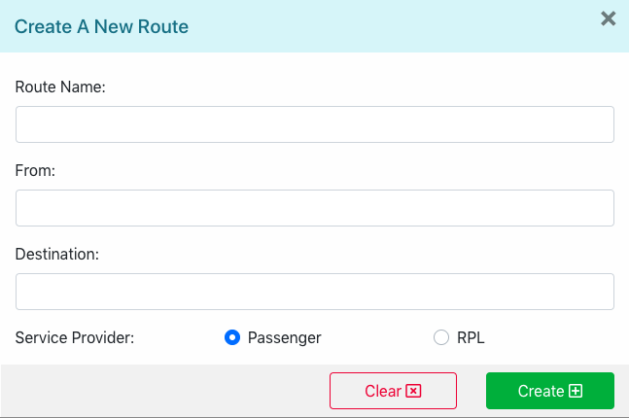

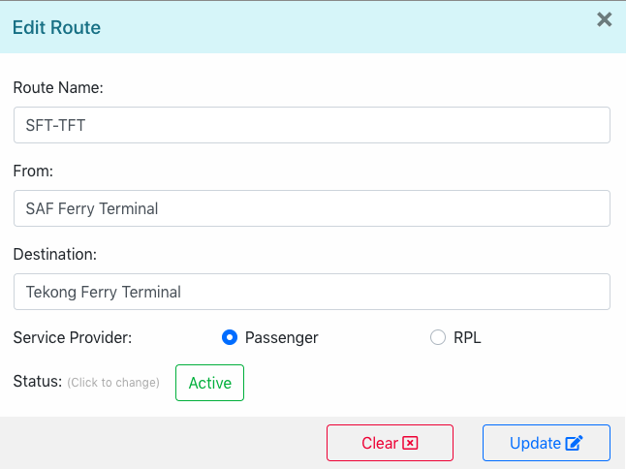

### Edit Route



### Activate/Deactivate Route



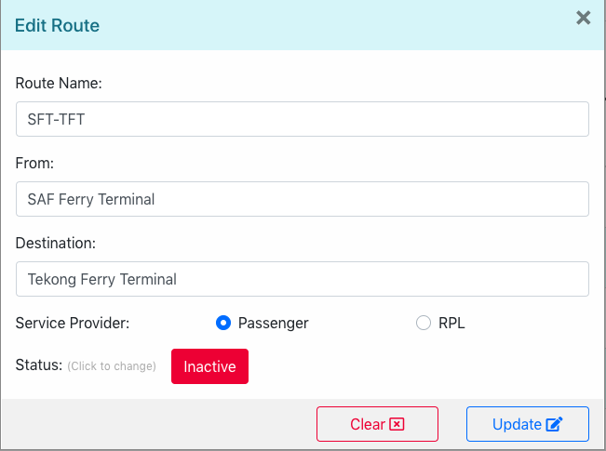

### Search Route



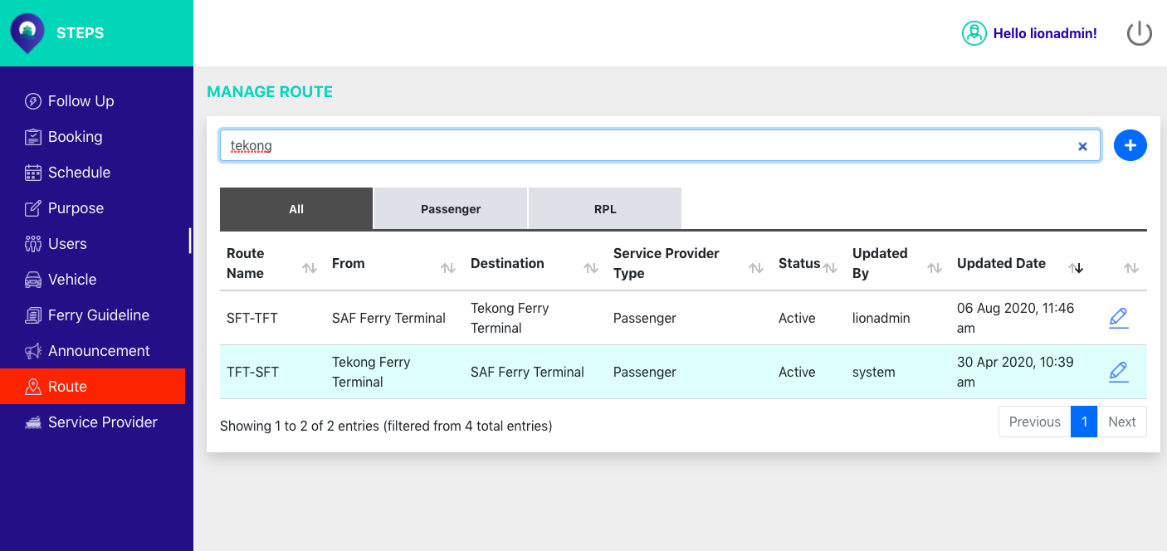

## Manage Service Provider

This function allows administrators to view, edit, create and search available service providers.

### View list of Service Provider

Step 1: Under the side menu bar, click ***Service Provider*** (*Figure 4.15.1.1*)***.***

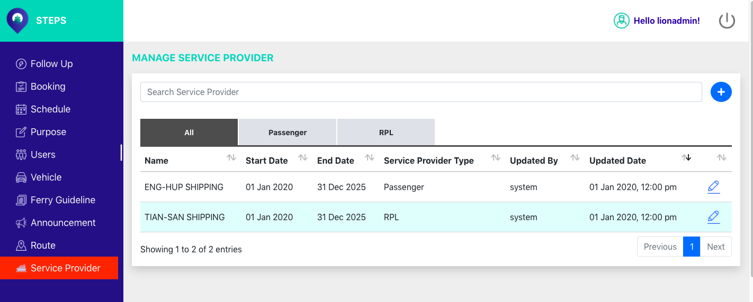

Figure 4.15.1.1: Service Provider Page

*Users are able to toggle among the different service provider tabs, such as* ***All, Passenger and RPL.***

*Passenger tab* (*Figure 4.15.1.2*).

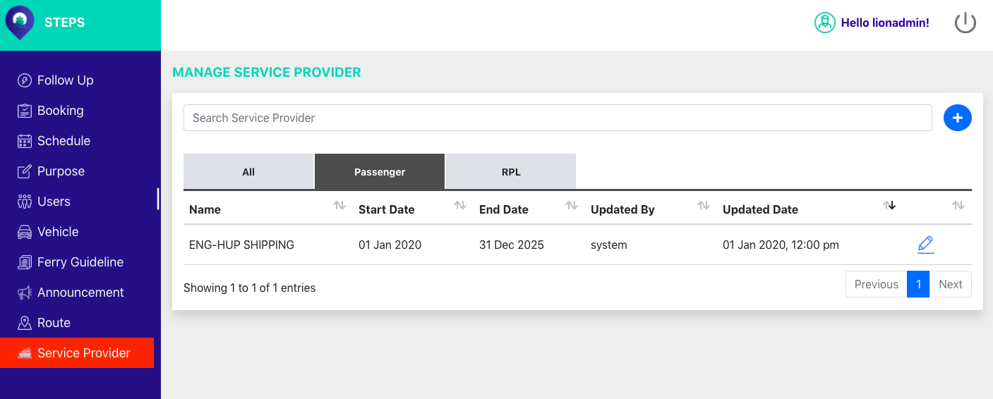

Figure 4.15.1.2: Service Provider Passenger tab

*RPL Tab (Figure 4.15.1.3).*

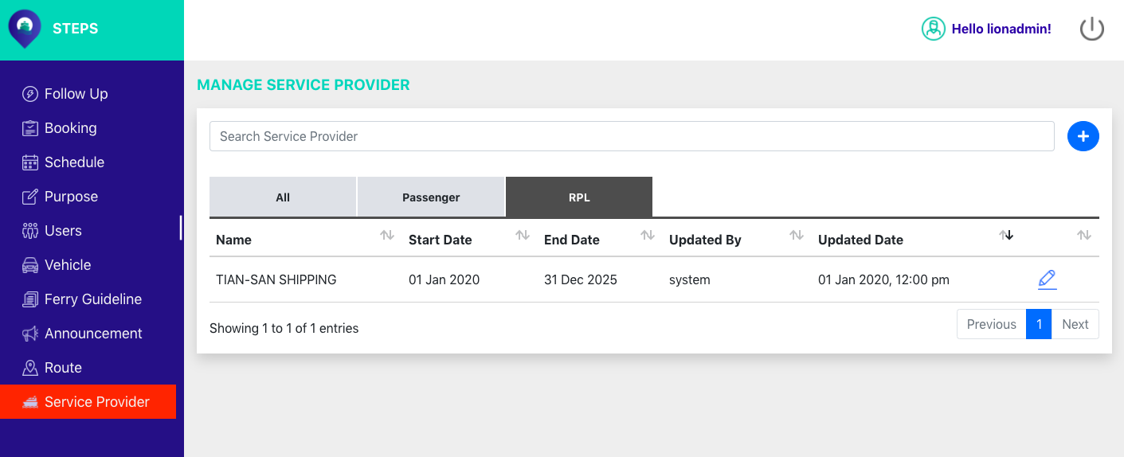

Figure 4.15.1.3: Service Provider RPL tab

### A screenshot of a cell phone Description automatically generatedCreate a new Service Provider

Step 1: On the ***Service Provider*** page, click on the button (*Figure 4.15.2.1*).



Figure 4.15.2.1: Create a new service provider button

*A pop-up box to create a new service provider will be shown* (*Figure 4.15.2.2*).

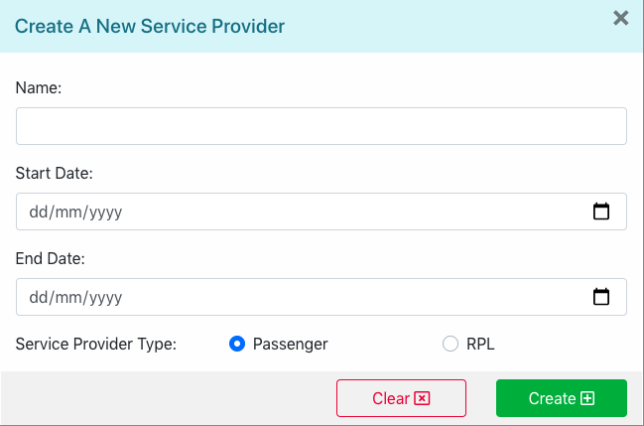

Figure 4.15.2.2: Create a new service provider pop-up box

Step 2: In the ***Name*** textbox, enter name.

Step 3: In the ***Start Date*** calendar option, choose a start date.

Step 4: In the ***End Date*** calendar option, choose an end date.

Step 5: In the ***Service Provider Type*** option, choose service provider type (Passenger/RPL).

Step 6: Click on ***Create*** to create a new service provider (*Figure 4.15.2.3*).

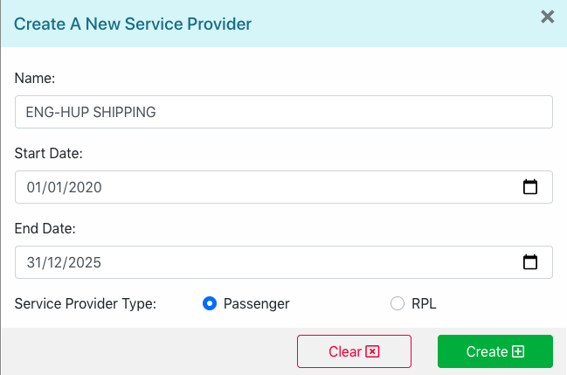

Figure 4.15.2.3: Create a new service provider

### A screenshot of a cell phone Description automatically generatedEdit Service Provider

Step 1: On the ***Service Provider*** page, click on the button (*Figure 4.15.3.1*).



Figure 4.15.3.1: Edit service provider button

*A pop-up box with the selected service provider details will be shown ().*

Step 2: In the ***Name*** textbox, edit name.

Step 3: In the ***Start Date*** calendar option, edit start date.

Step 4: In the ***End Date*** calendar option, edit end date.

Step 5: In the ***Service Provider Type*** option, edit service provider type (Passenger/RPL).

Step 6: Click on ***Update*** to edit a new service provider (*Figure 4.15.3.2*).

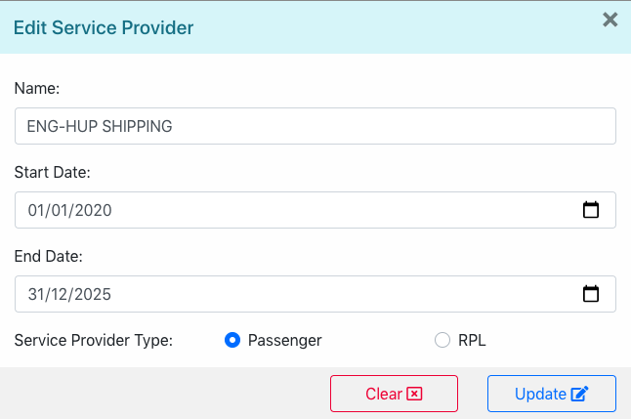

Figure 4.15.3.2: Edit Service provider

*The changes made to the selected service provider will be shown on the list.*

### Search Service Provider

On the ***Service Provider*** page, administrators are able to search for specific service provider with relevant search terms using the search bar located at the top of the page (*Figure 4.15.4.1*).



Figure 4.15.4.1: Search Service Provider

*E.g. The list will display results that contains the search term “tian” (Figure 4.15.4.2).*

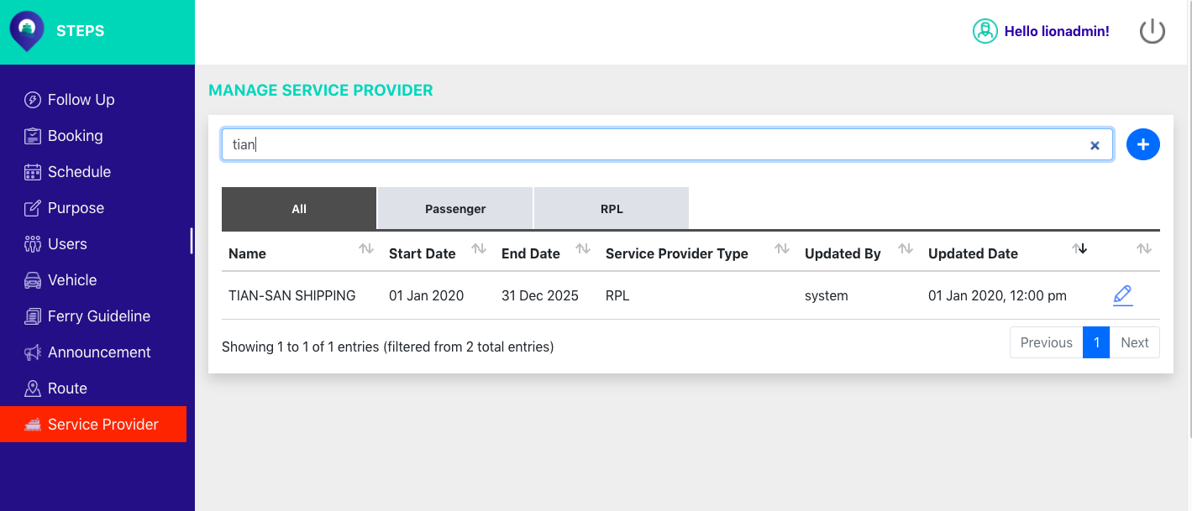

Figure 4.15.4.2: Search term service provider

## A screenshot of a cell phone Description automatically generatedLog out

On the top right corner of the page, click on the button to log out (*Figure 4.16.1*).



Figure 4.4.15.4.16.1: Log out button

*Users will be redirected back to login page (*Figure 4.16.2*).*



Figure 4.16.4.15.4.2: Login Page

**END OF DOCUMENT**